General assembly
This document is the description of the main components of the setup and their assembly. Most of the components have been designed from scratch using a Soliworks® 2018 educational license and others have been downloaded from the Thorlabs® products page.
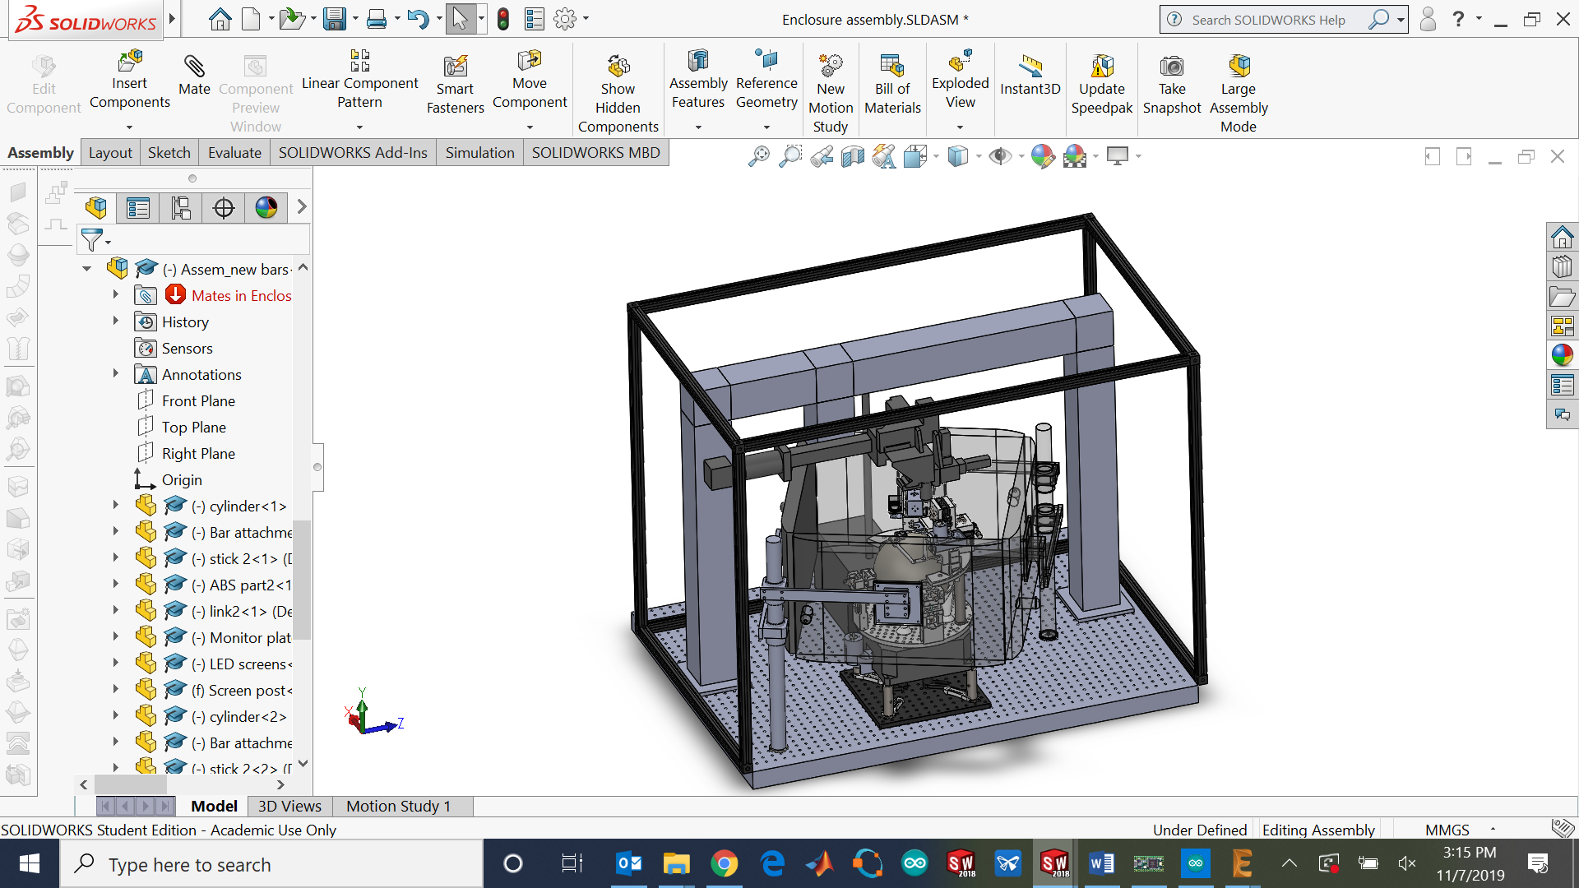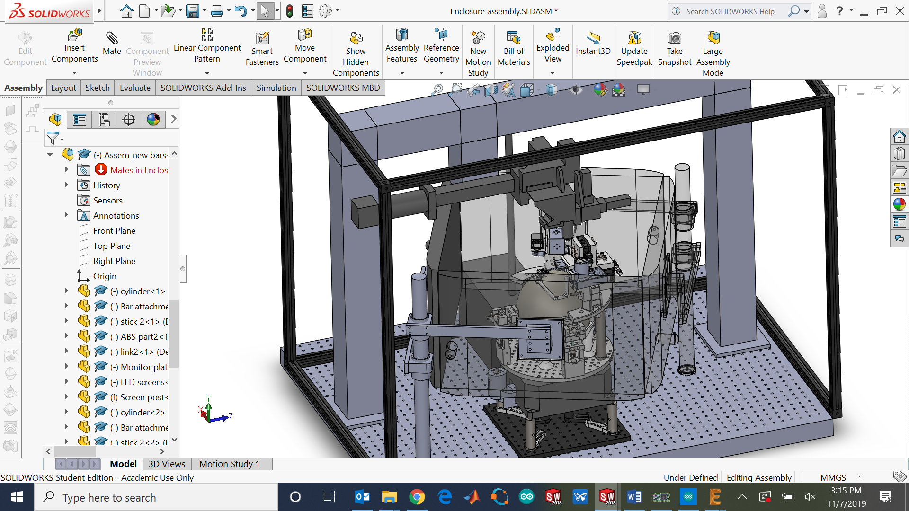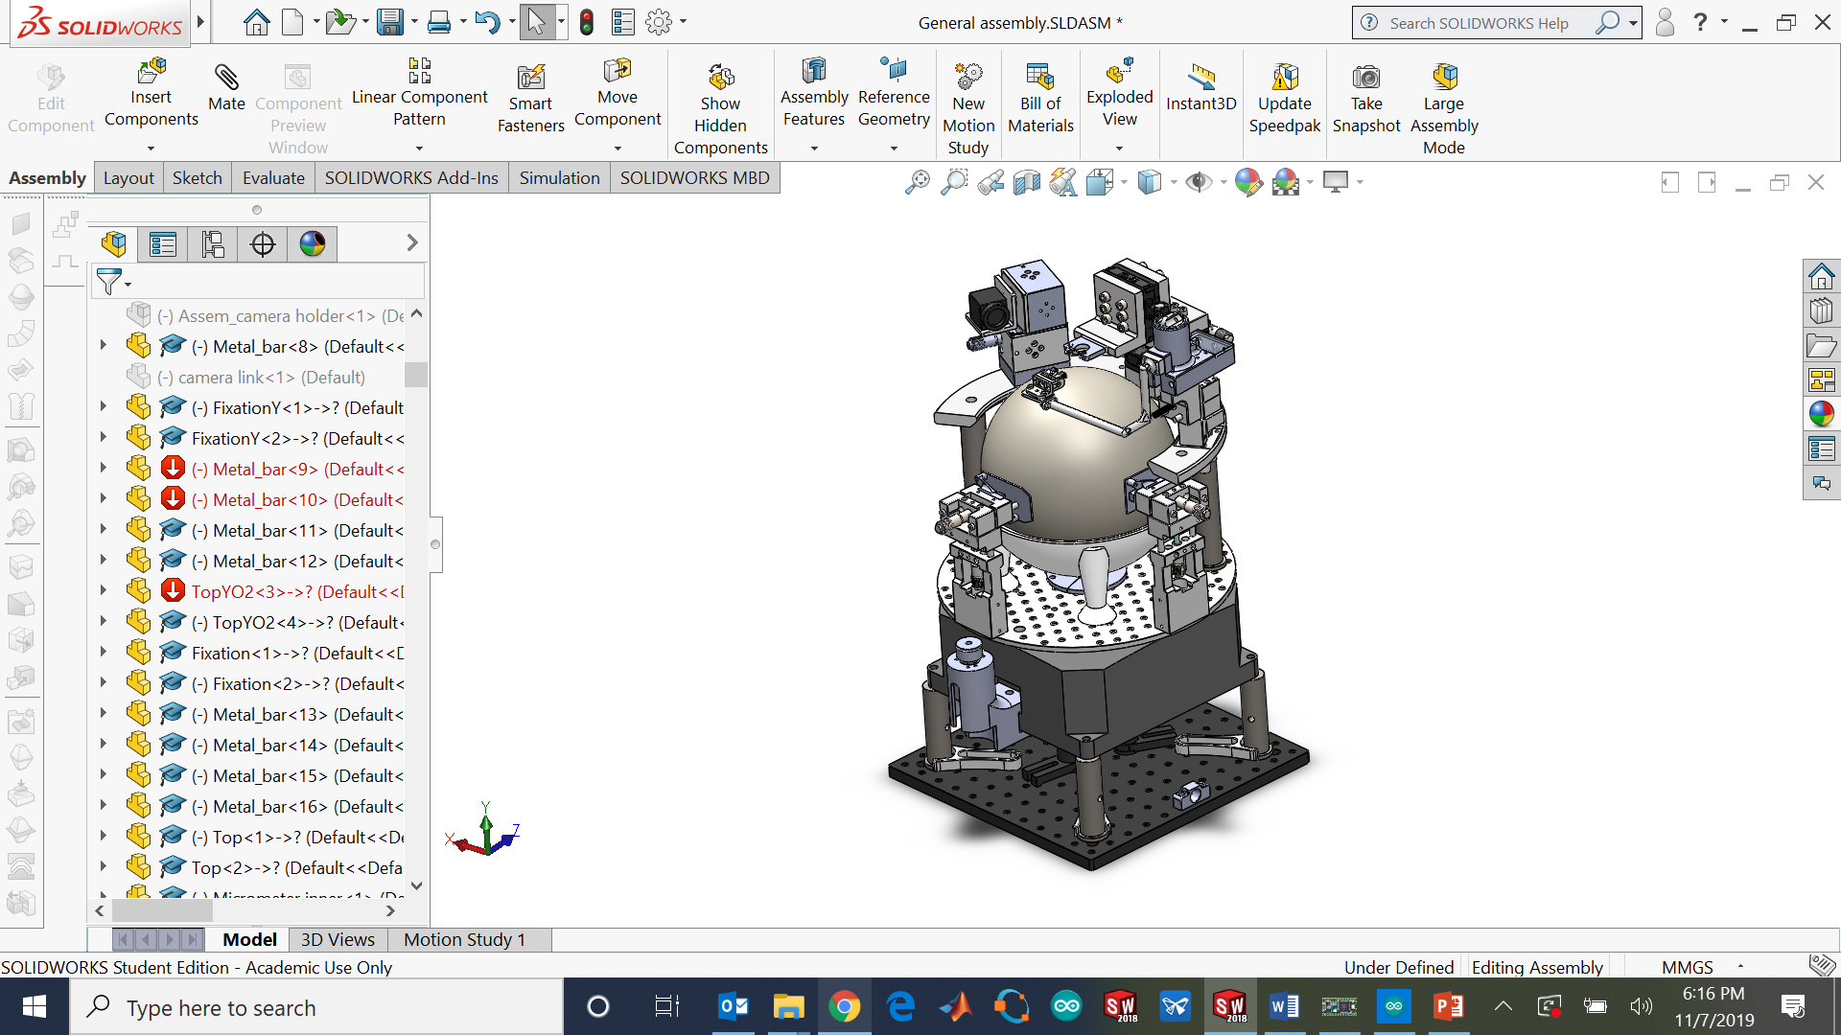
Figure 1: Main components on the CAD software.
The square platform Thorlabs® MB 3030 is the baseplate used for attachment to the optics table.
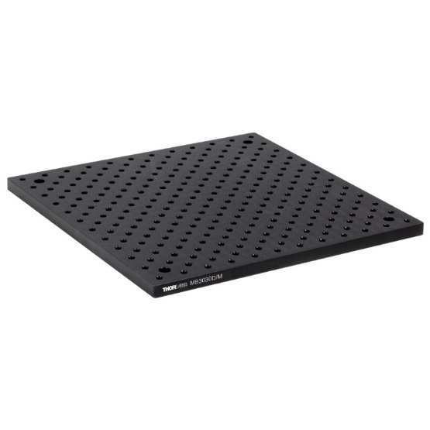
Figure 2: Thorlabs MB 3030 [1].
The rotary stage Steinmeyer® DT240 is held by the square platform and four Thorlabs RS3.5P_M 25 mm posts.
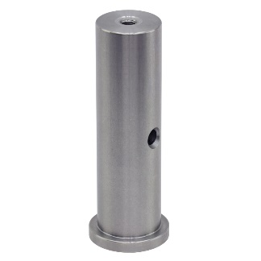
Figure 3: Thorlabs RS3.5P_M [2].
The four posts are clamped to the MB 3030 square platform with four CF175-P5 clamping forks.
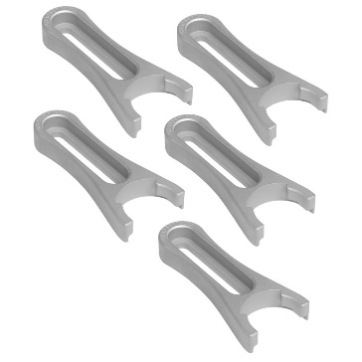
Figure 4: Thorlabs® CF175-P5 [3].
The new rotary stage is a DT240 rotary stage from the manufacturer Steinmeyer® [4]:
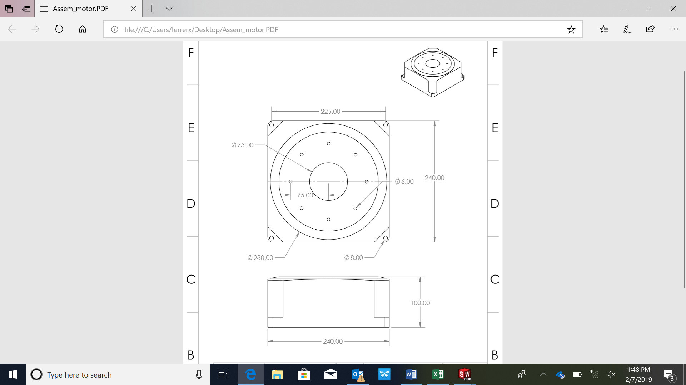
Table 1: Rotary stage features.
Travel [deg] | n x 360
Repeatability unidirectional [deg] | ± 0.0001
Repeatability bidirectional [deg] | ± 0.0002
Accuracy [deg] | ± 0.002
Excentric runout [µm] | ± 2.5
Positioning speed [deg/s] | 1500
Max. acceleration [deg/s^2] | 30000
Max. load Fz [N] | 400
Max. load torque Mz [Nm] | 8
Max. load torque Mx,y [Nm] | 71
Weight [kg] | 16.2

Figure 5: Steinmeyer DT240 view and dimensions.
The circular platform that is the joint between the rotary stage and the other elements on the top is based on the Thorlabs MBR300U with all the holes with an M6 hole except the modifications made on the drawing (Figure 6) and the holes for the two IR optical flow sensor stages. This one is attached with the rotary stage by eight M6 screws. The drawings can be found on the drawings folder. The thickness of the platform must be 6 mm.The steps to drill the holes needed on the platform are the following ones:
- The central hole must be 56 mm diameter to fit the rotary joint spacer.
- The holes where Attachment 2 is fixed must be M6 treaded holes.
- The 8 holes used to attach the rotary stage must be 6 mm with no thread.
- The 4 holes to attach the sphere holder must be M6 threaded holes.
- The two holes made to hold the Optical mouse sensor holders (red arrows) must be 6 mm without thread and the other three with thread.
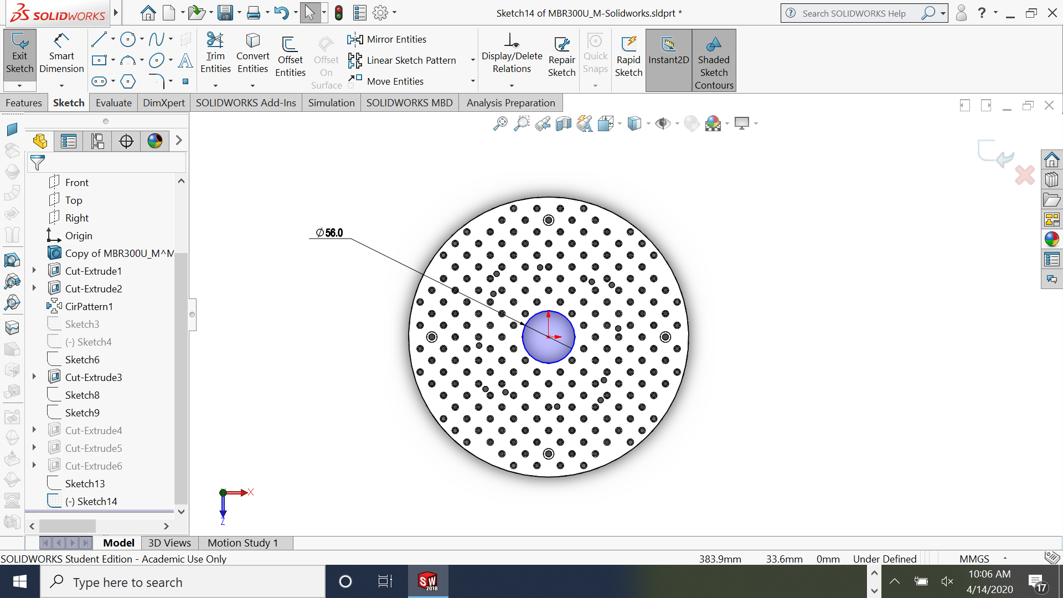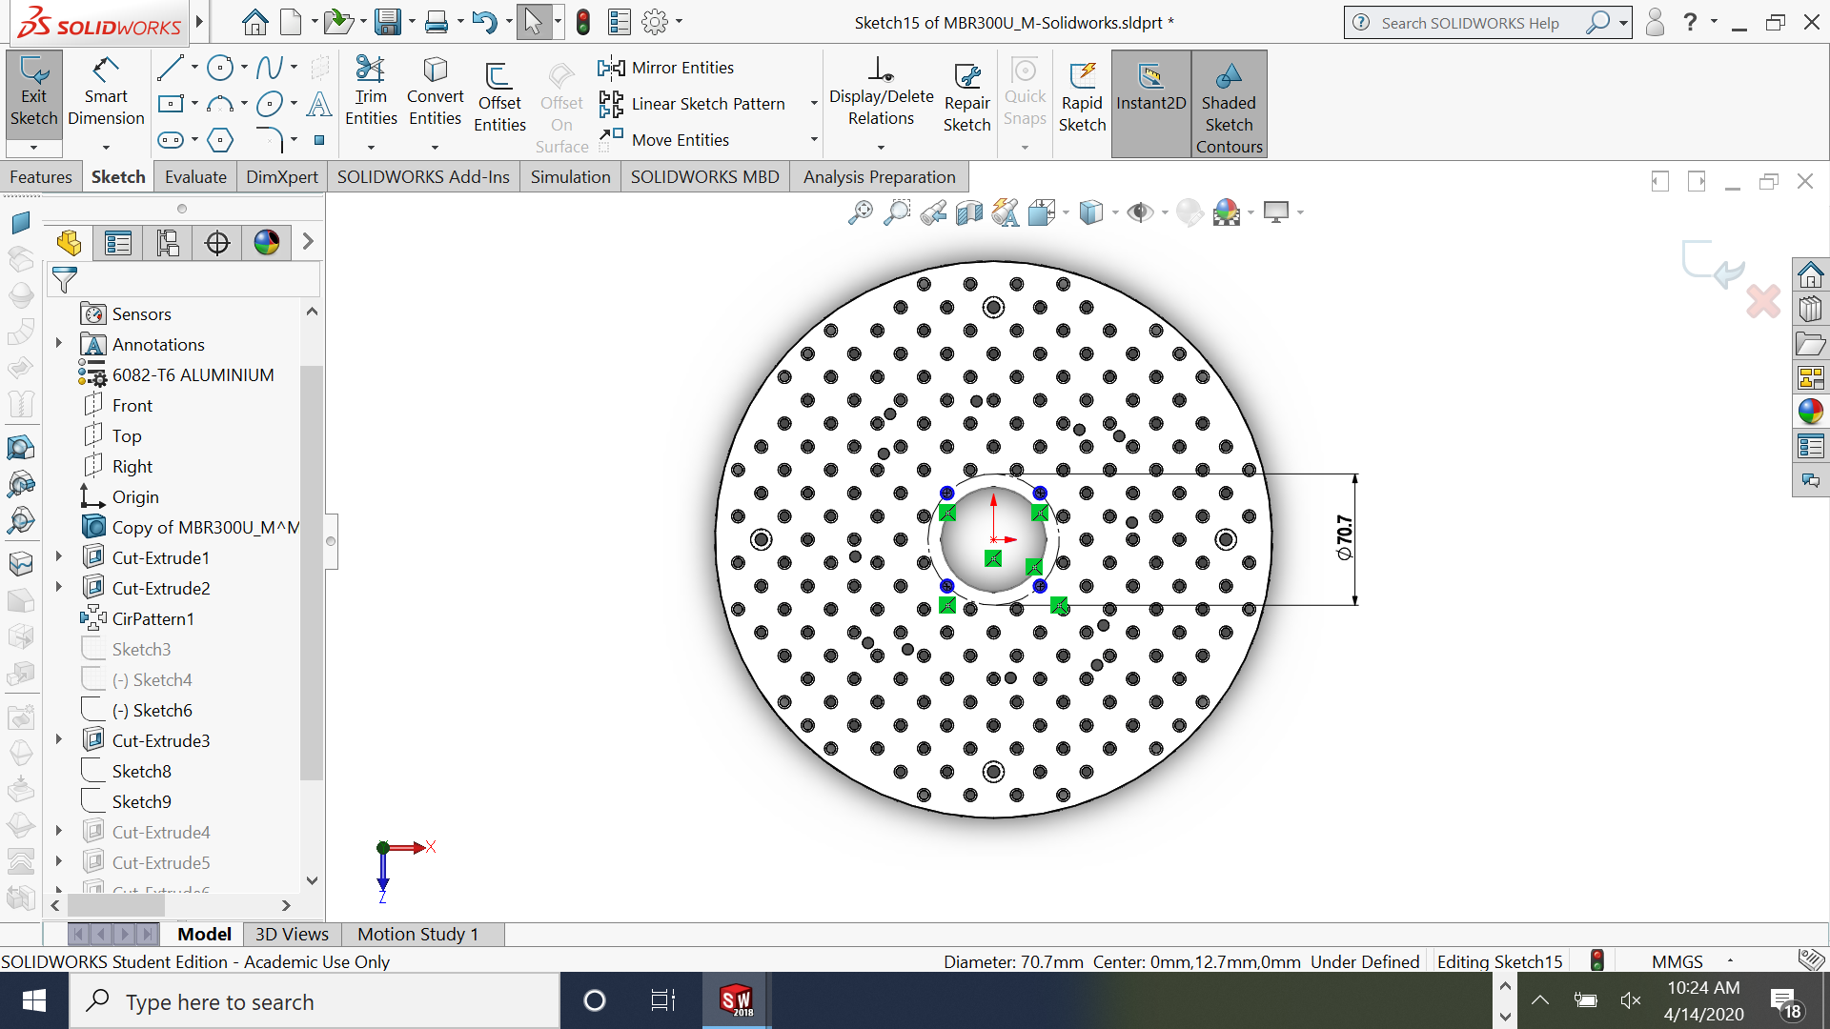
b
a
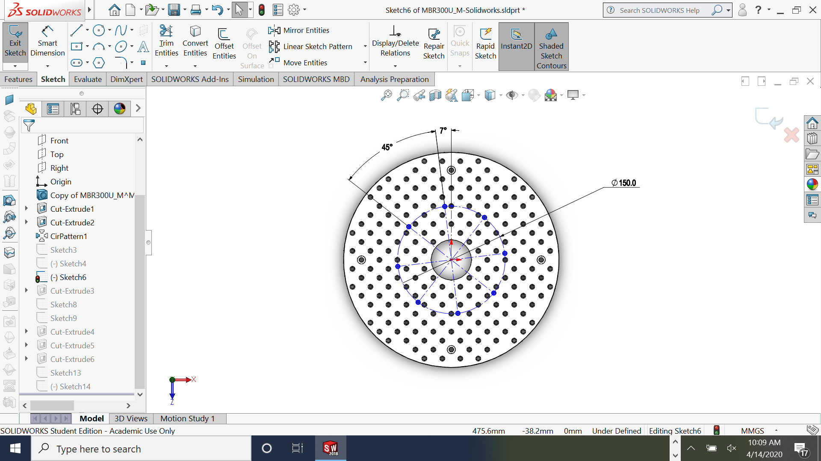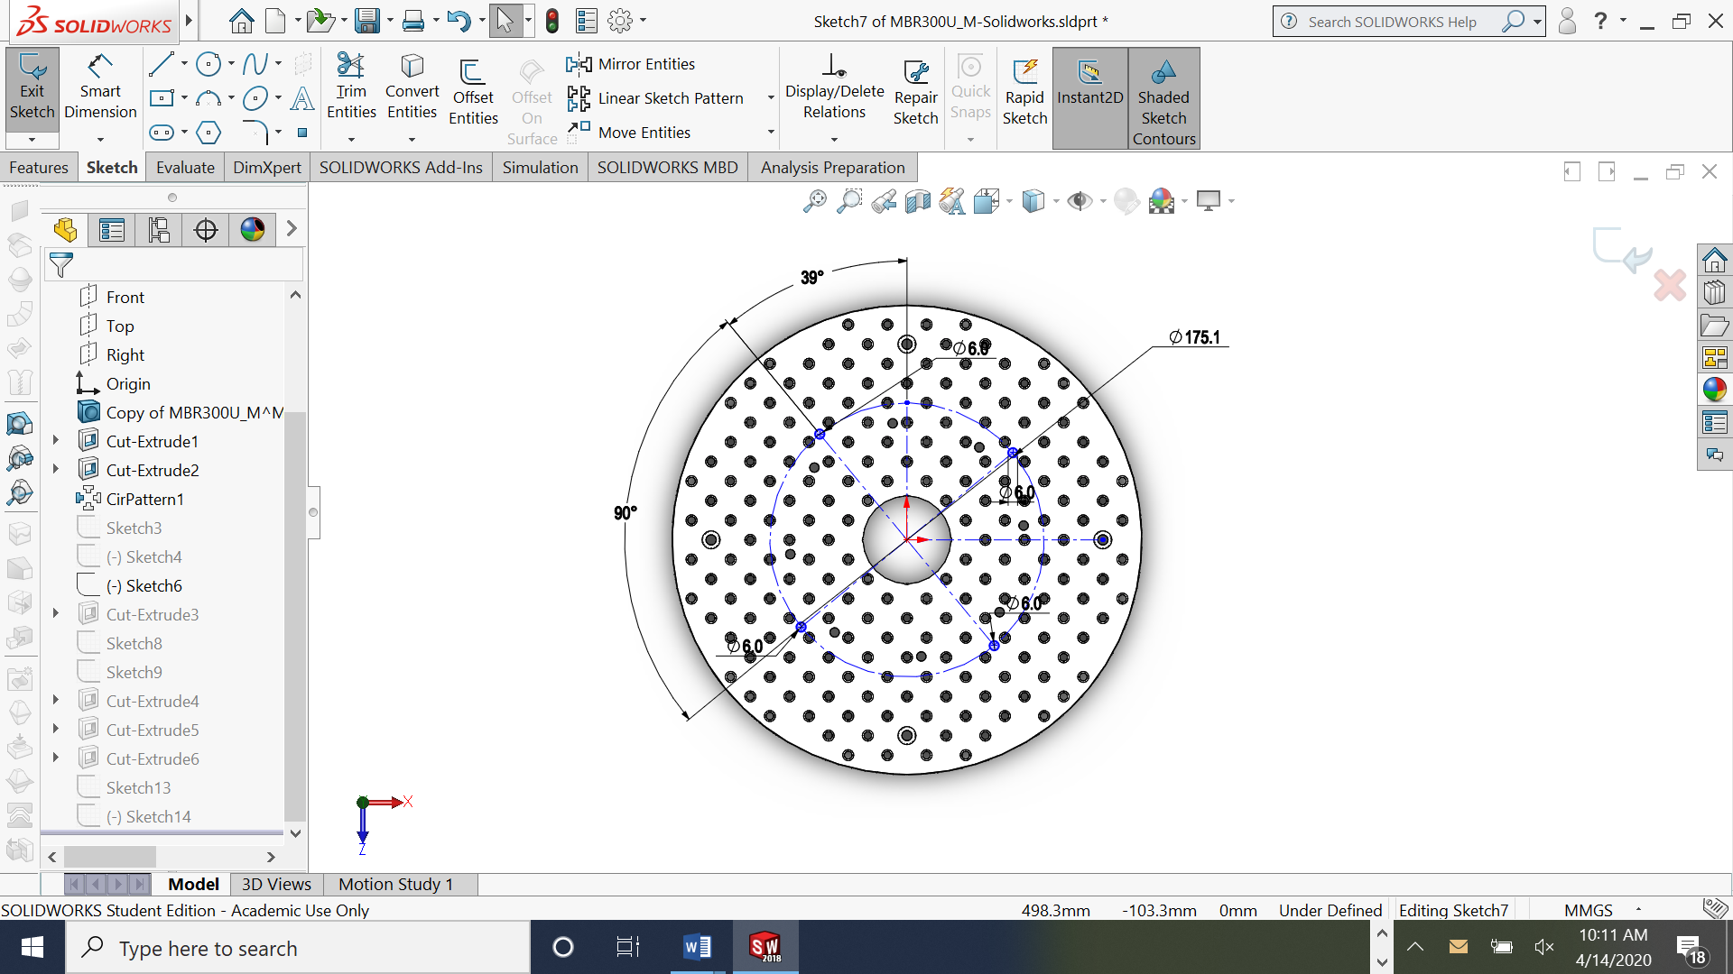
c
d
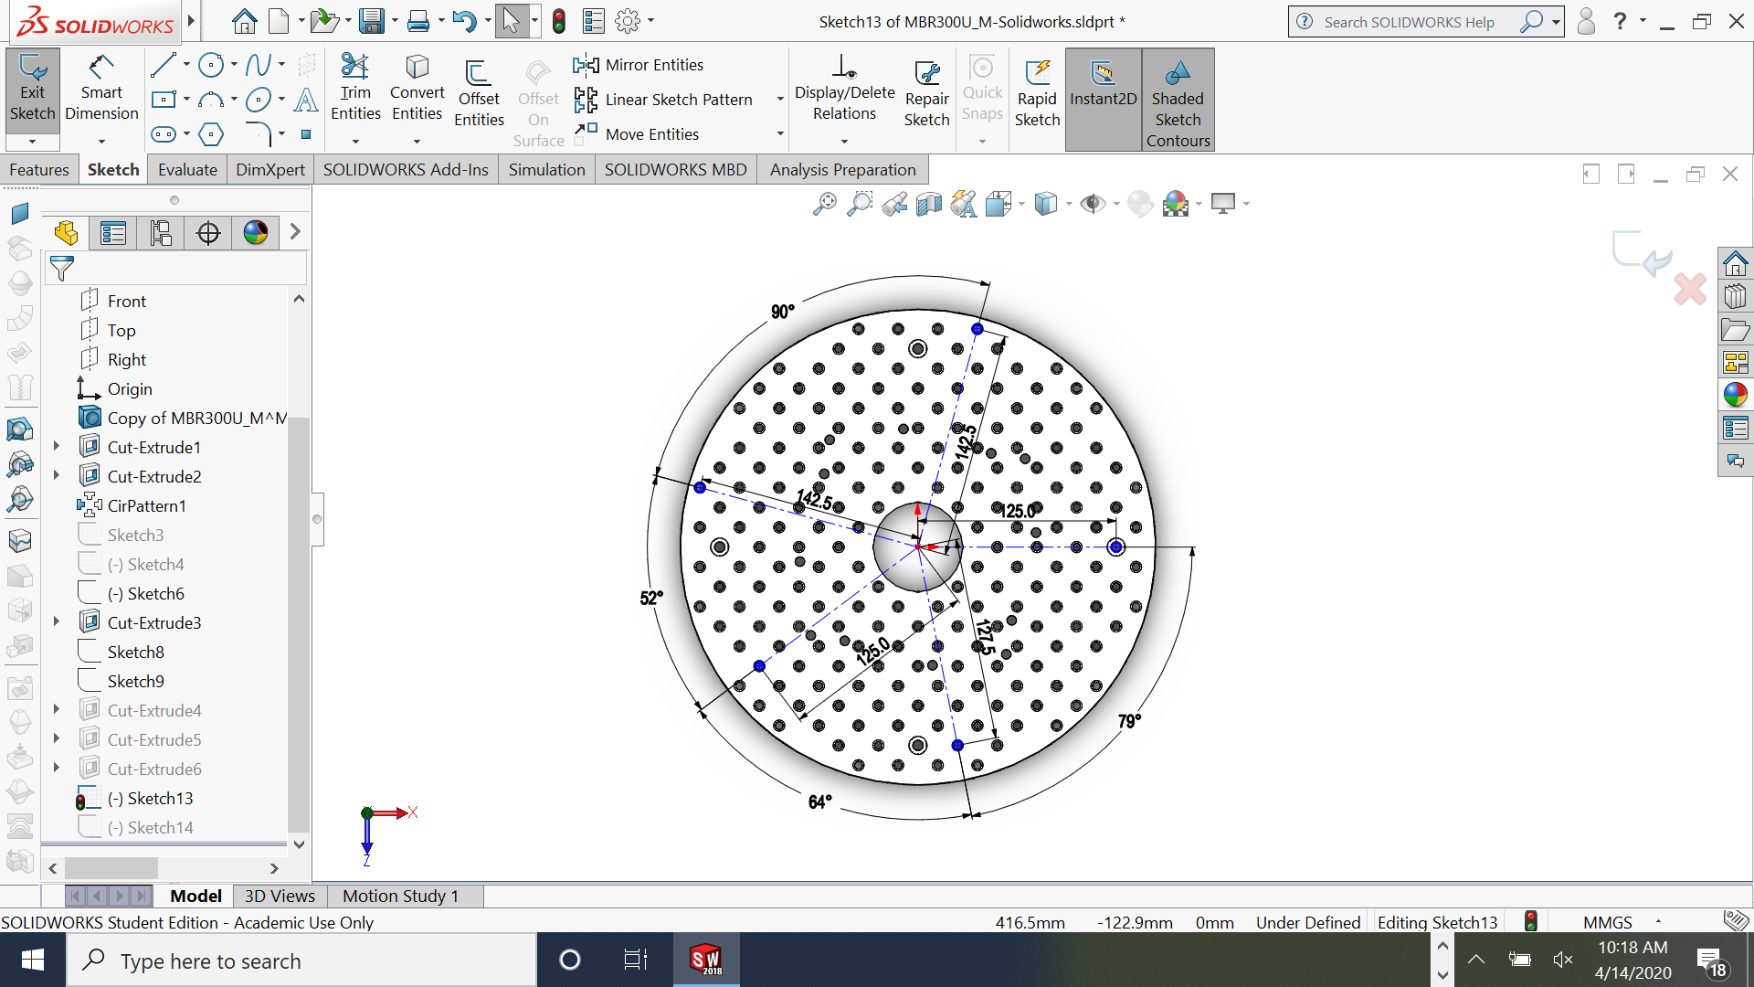
e

Figure 6: Circular platform steps.
The slip ring is attached to the square platform using two Thorlabs UPH50_M universal post holders combined with two Thorlabs TR50_M 12.7 mm posts.
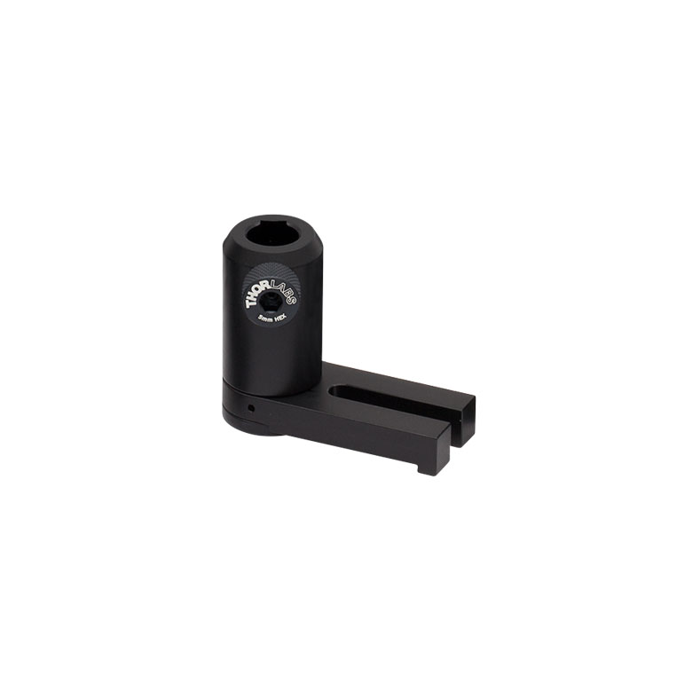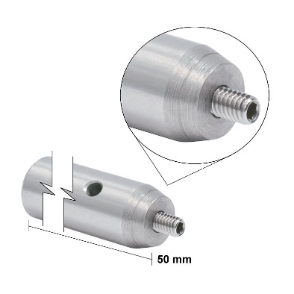
Figure 7: UPH50_M [5] and TR50_M [6].

The slip ring or rotary joint is the element which enable communications between all sensors and active devices placed on the rotary platform and the static square base. This rotary joint is the Senring SNU11-15S-52301 [7].
Table 2: Rotary joint features.
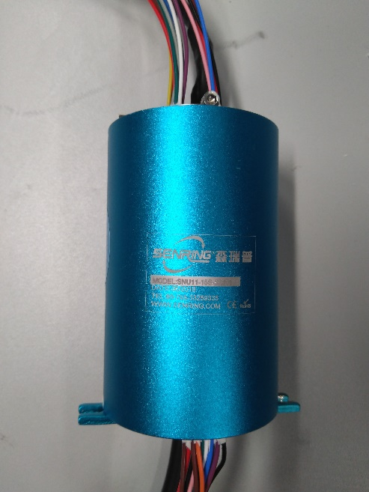
USB | 1 or 2
Working life | 20M
Rotating speed | 0-400 rpm
contact material | precious metal
housing material | Aluminium alloy
torque | 0.1 Nm
voltage range | 440V AC
Insulation resistance | 1000 Mohm a 500VDC
Dielectric strength | 499 VAC a 50 Hz
Electrical noise | 10 mohm
CE mark | yes
Protection degree | IP50
Bit rate error | 1.00E-11

Figure 8: Senring SNU11-15S-52301.

The air tube guide has been designed to orientate the tube across the square platform. This part has been printed with a From2 3D printer with clear v4 resin.
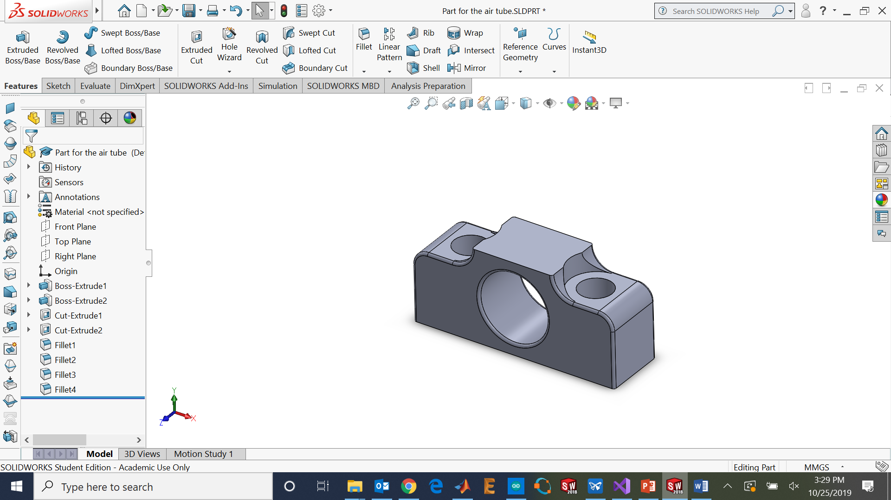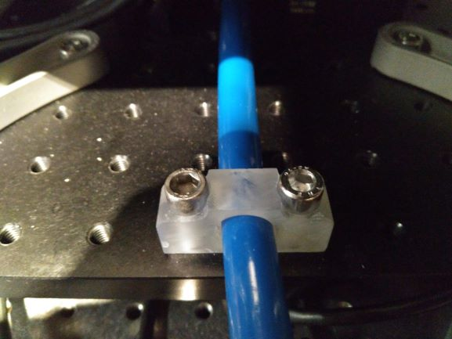
Figure 9: Air tube guide.
The M6 screws to attach the motor with the four Thorlabs 25 mm bars are modified 50 mm screws removing part of the thread (only 9 mm o thread remaining).
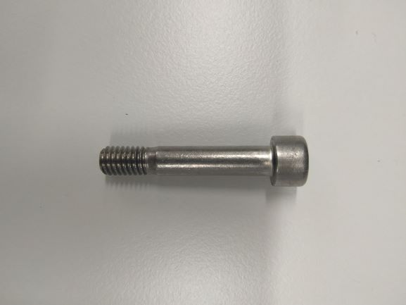
Figure 10: Modified M6 screws.

The tube used for the air circuit is a 12 mm OD and 8 mm ID pneumatic tube.
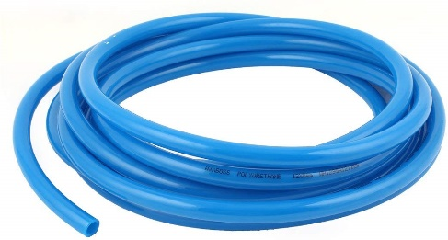
Figure 11: Pneumatic tube.
A 90-degree elbow tube connection has been used to redirect the horizontal tube to the vertical insertion below the sphere holder.
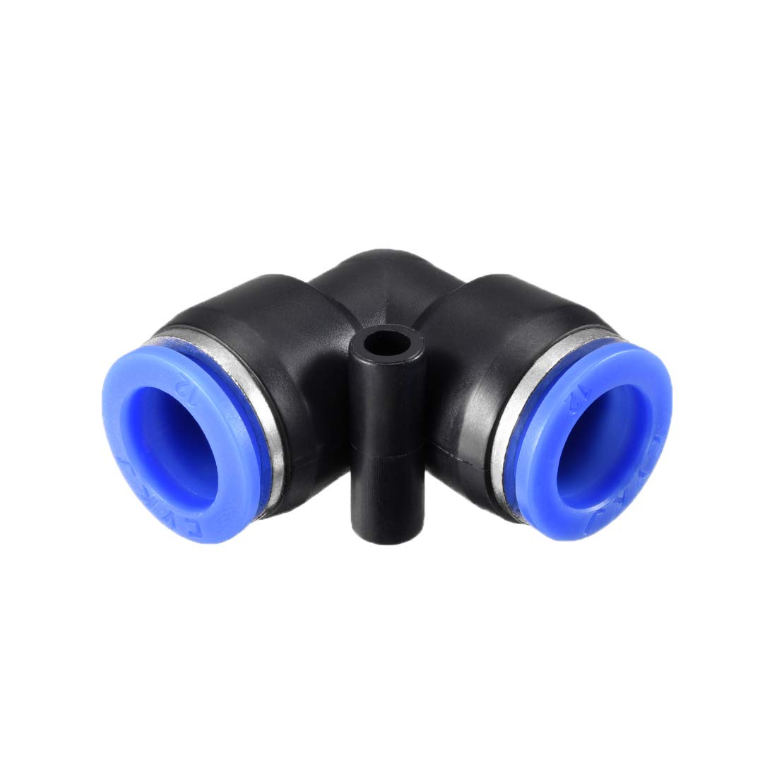
Figure 12: Pneumatic elbow connection.
The Rotary joint spacer is the part needed to fill the space between the circular platform and the slip ring. And also actuates to transmit forces between the two parts. The drawings can be found on the drawings folder.
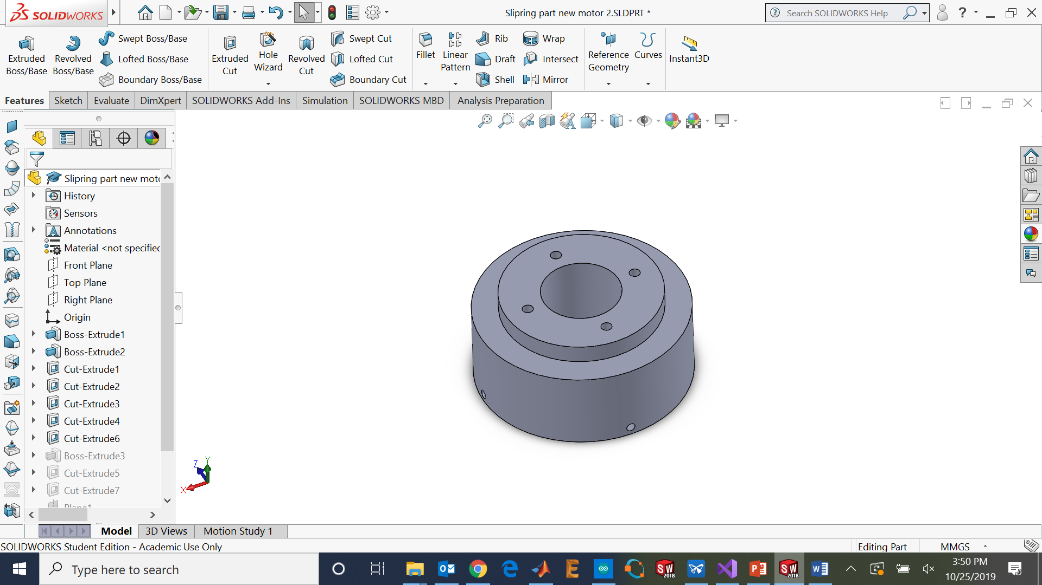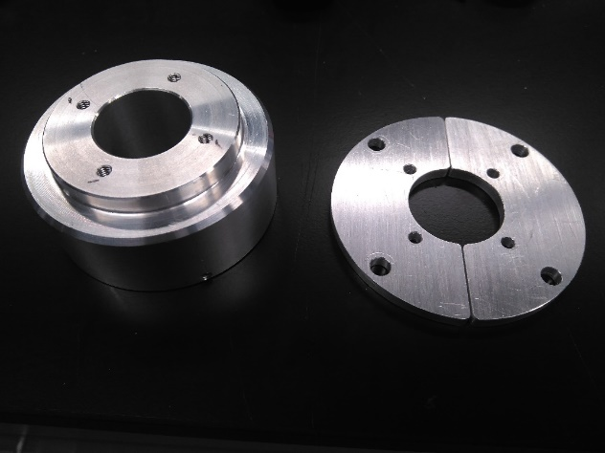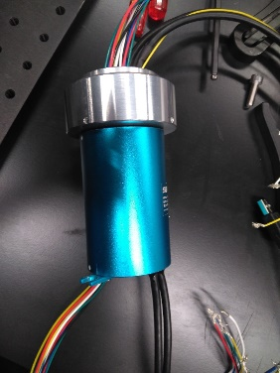
Figure 13: Rotary joint spacer CAD design and real pictures.
The spacer fills the space between the circular platform and the rotary joint spacer.
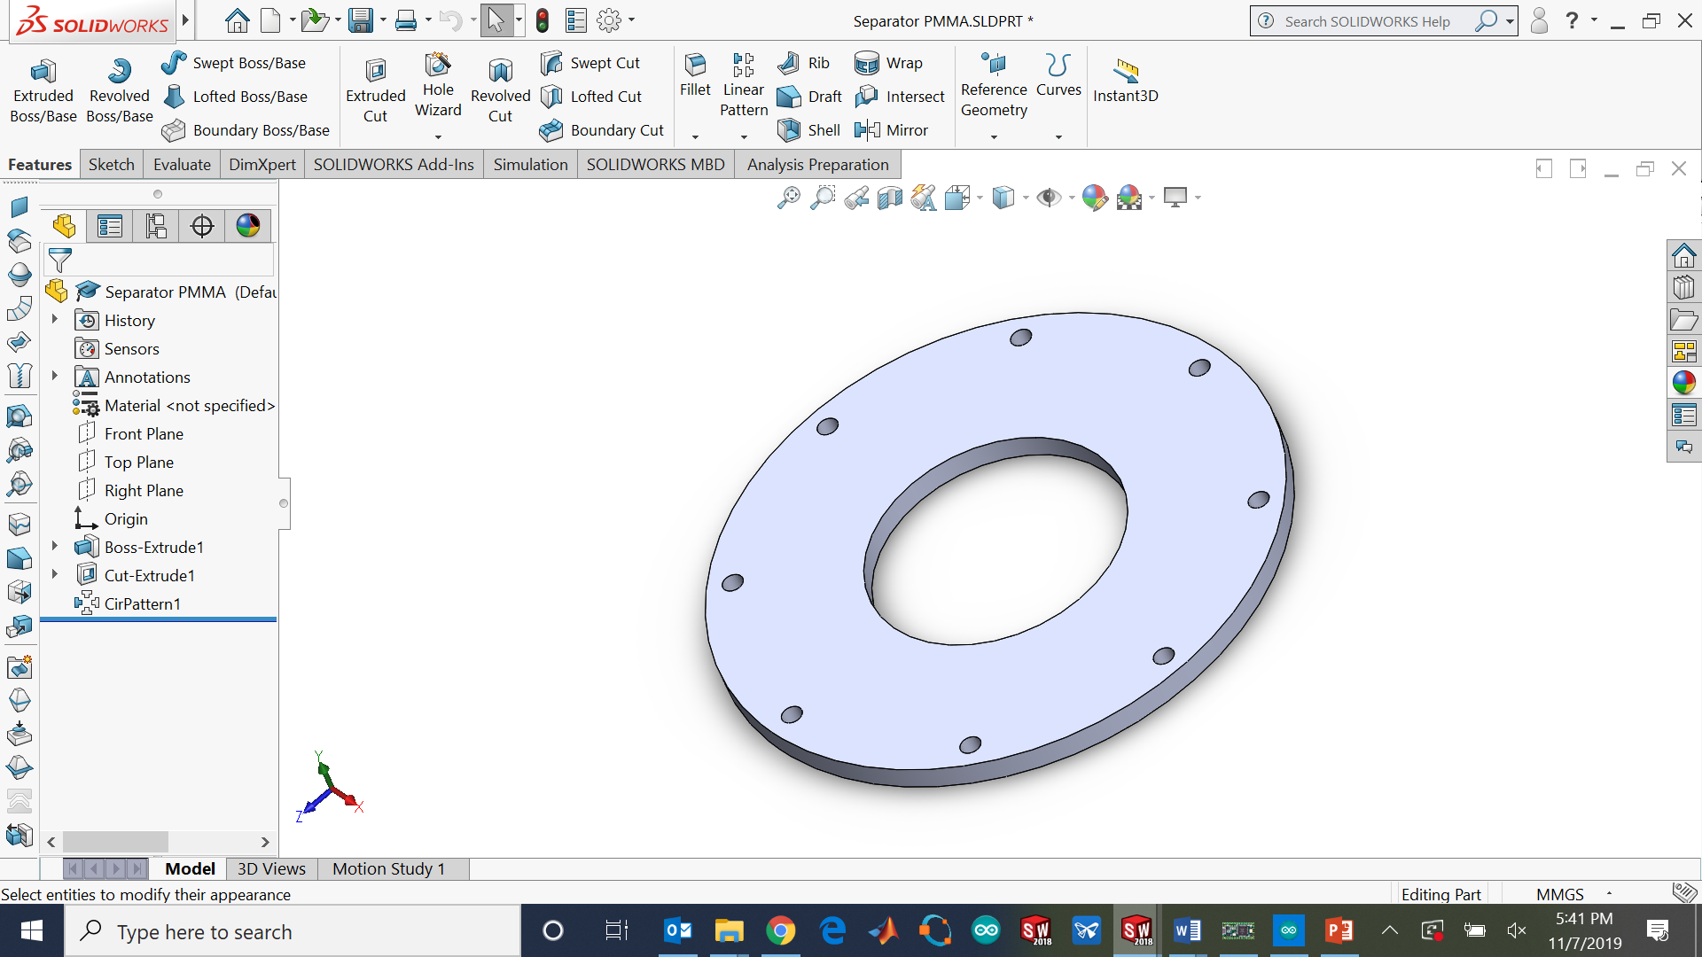
Figure 14: Spacer.
The Attachment 2 are the aluminum parts to attach the circular platform and he rotary joint spacer. The drawings can be found on the drawings folder.

Figure 15: Attachment 2.
The sphere is a polystyrene ball of 197 mm diameter. The two parts are glued with white glue.
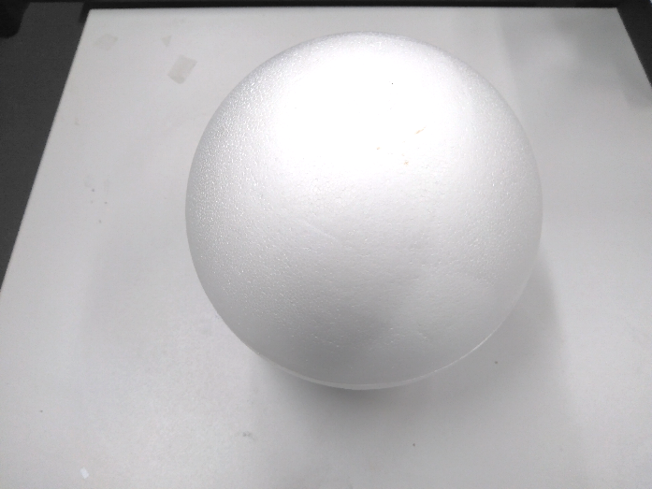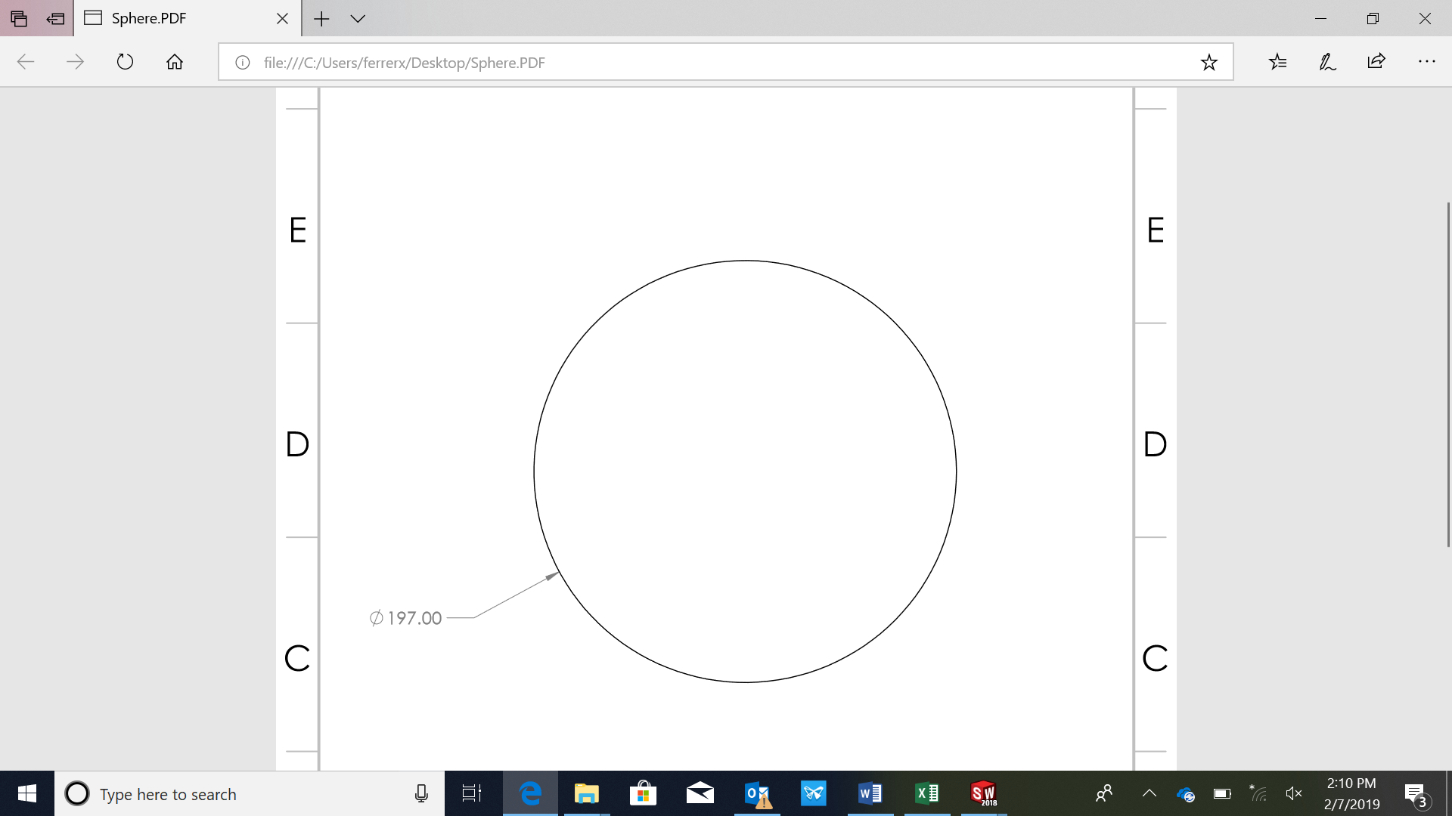
Figure 16: polystyrene sphere appearance and dimensions.
The cable clamps have been designed to hold the cables on the circular platform.
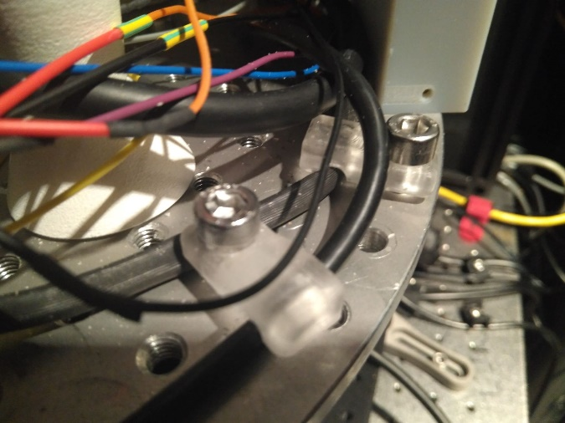
Figure 17: Cable clamps.

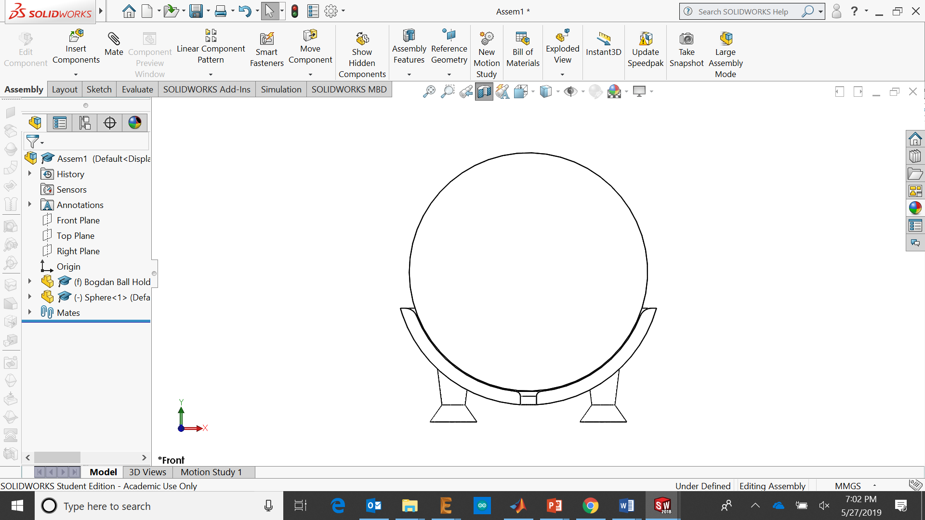
The sphere holder was designed by Bogdan Horobet in 2016. The compressed air is injected from below using the pneumatic 12 mm tube.
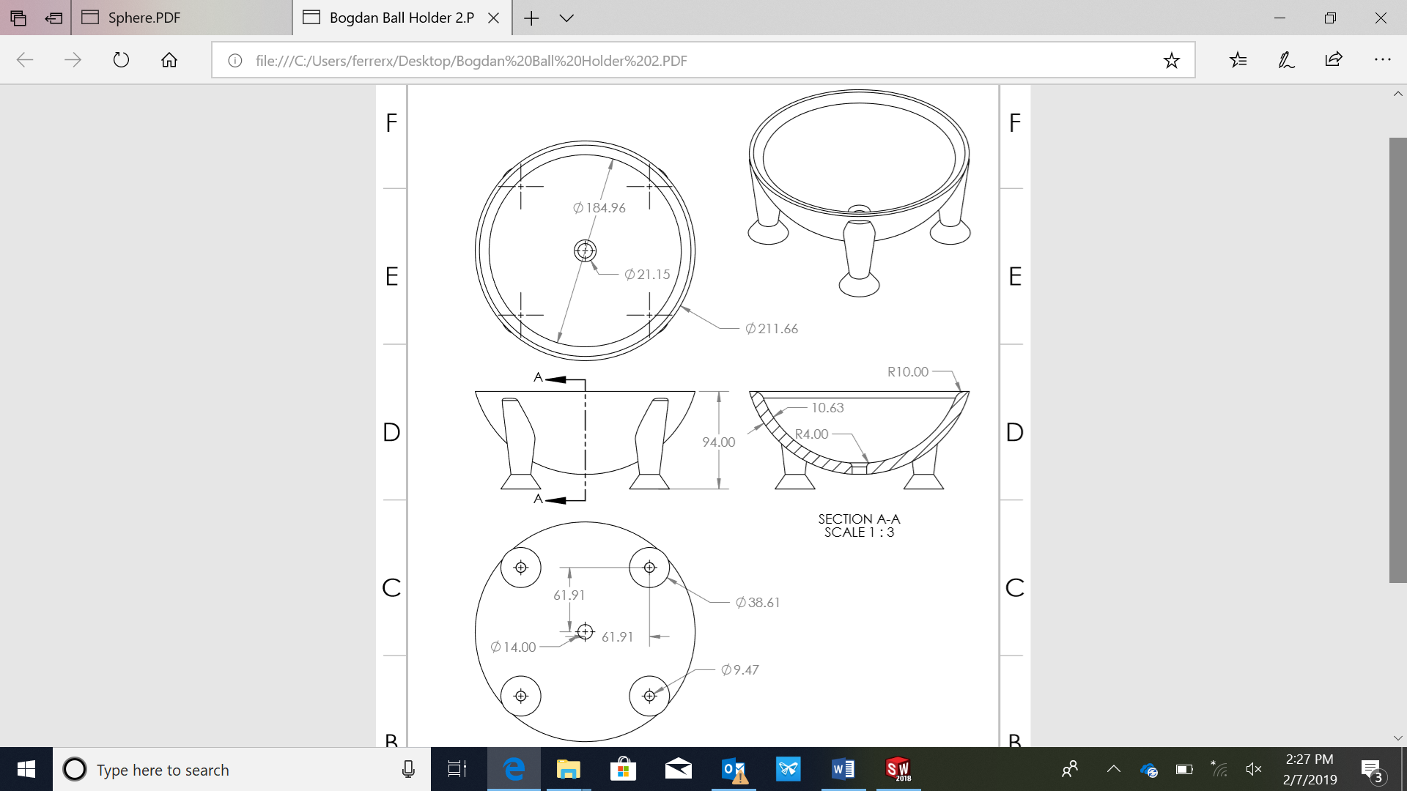
Figure 18: Horobet sphere holder drawing.

In the last version of the device the four legs where modified adding a space to insert the M6 screws from the top.
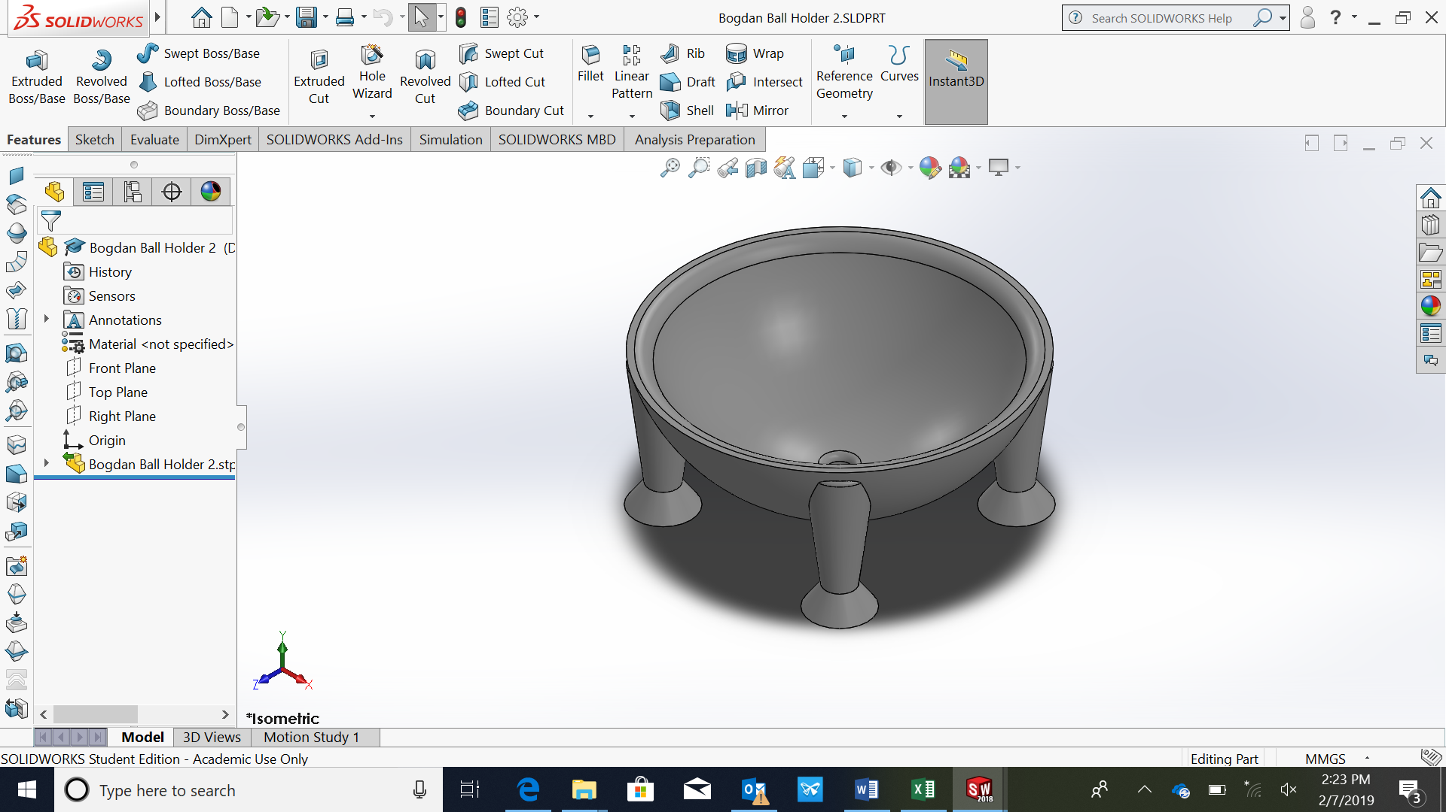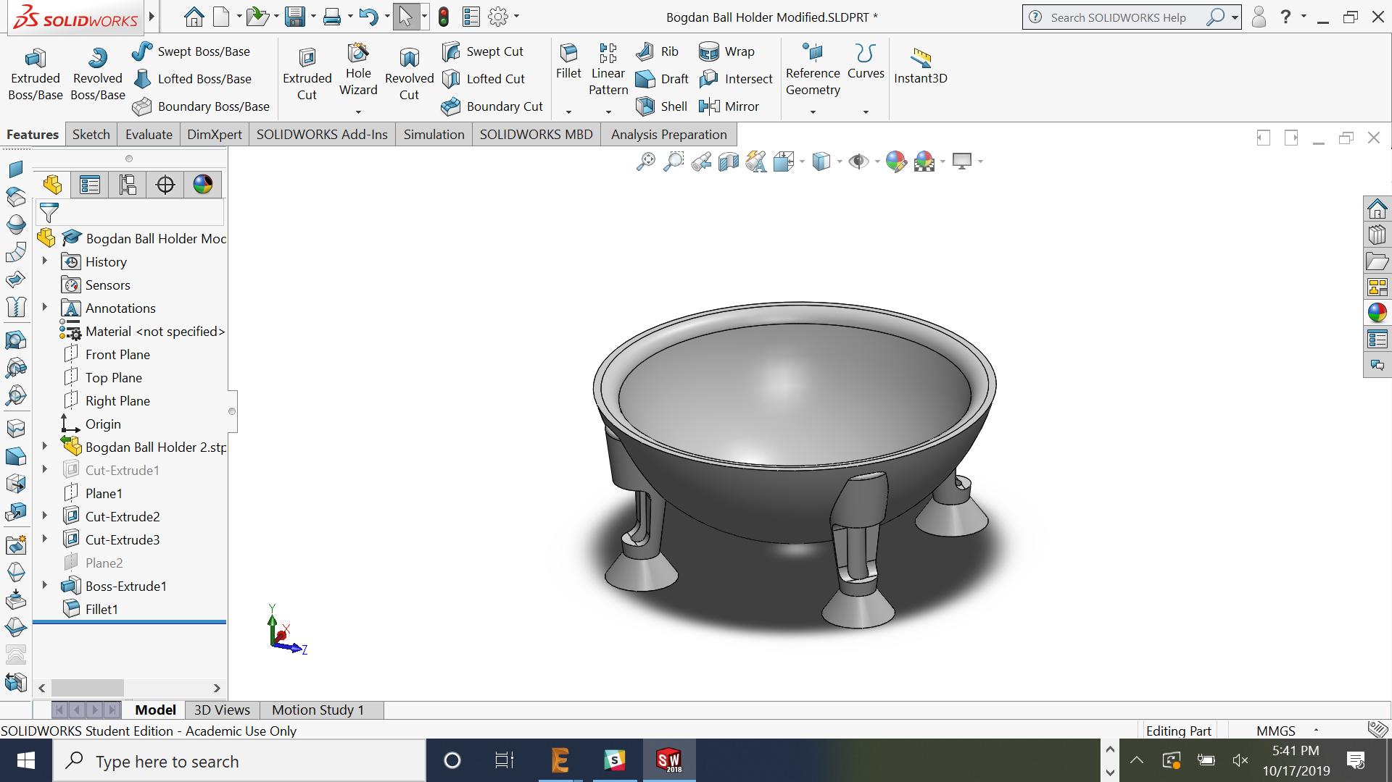
Figure 19: Horobet sphere holder CAD initial version and modified version.
Three Thorlabs RS6P_M posts hold the two circular rings.
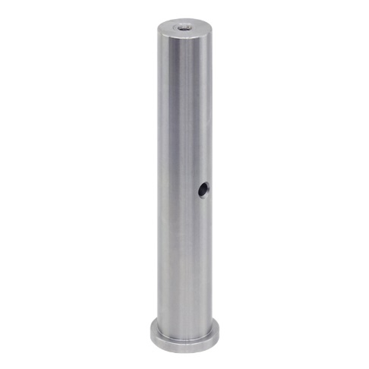
Figure 20: RS6P_M post [8].
The two circular rings are holding the reward delivery system, the head fixation system and the pupil tracking camera.
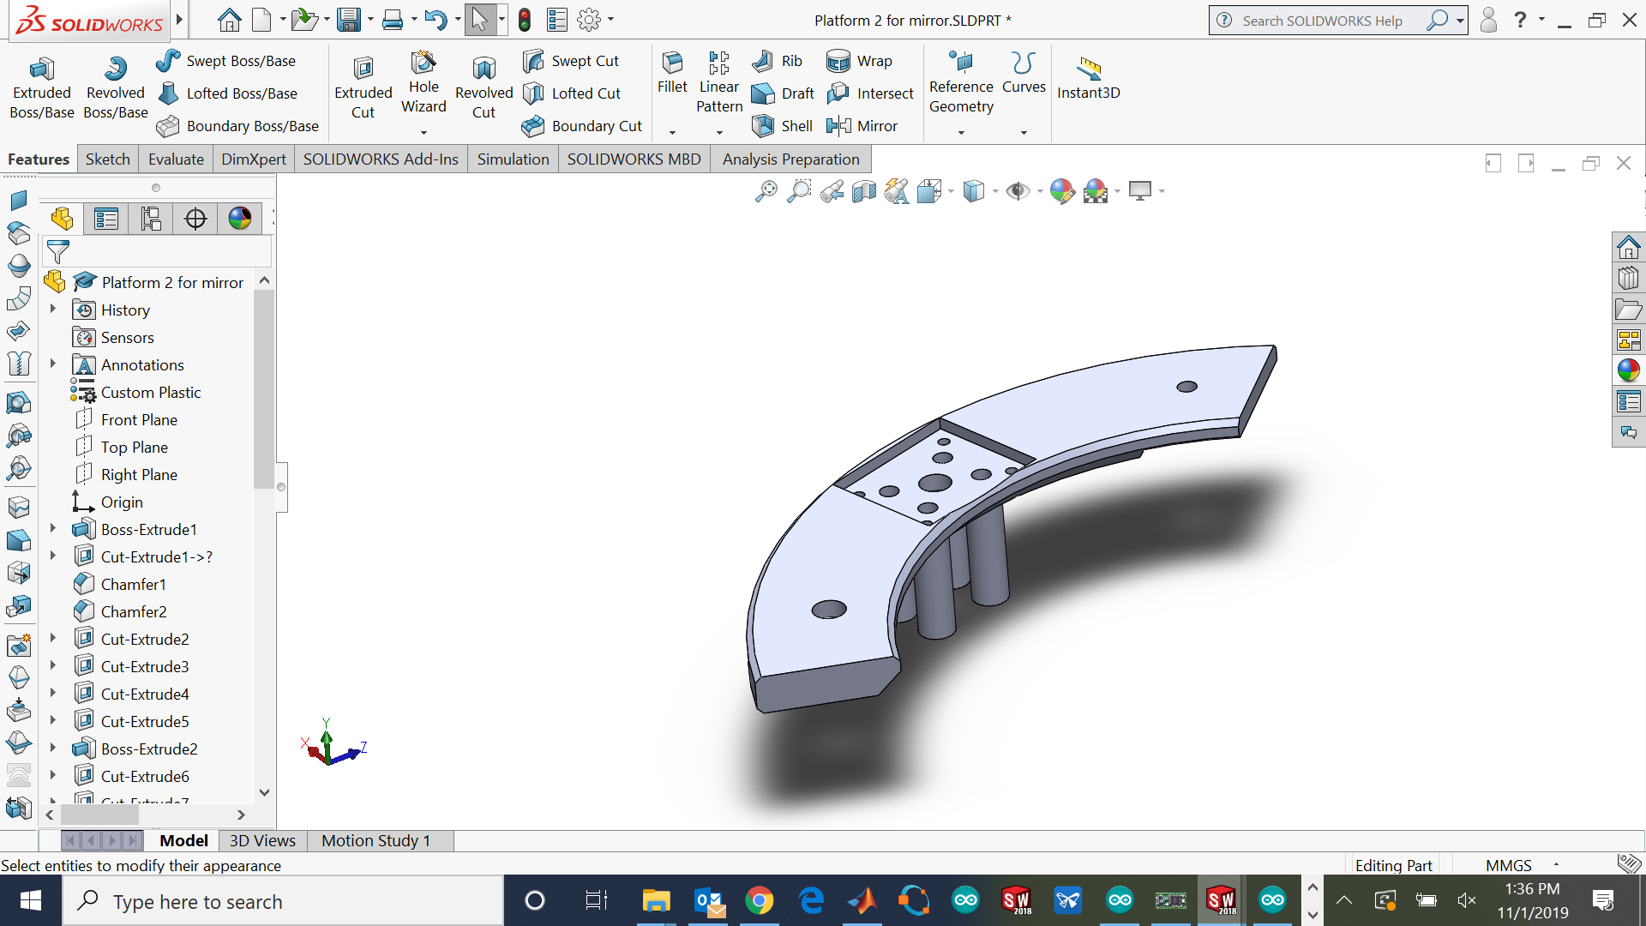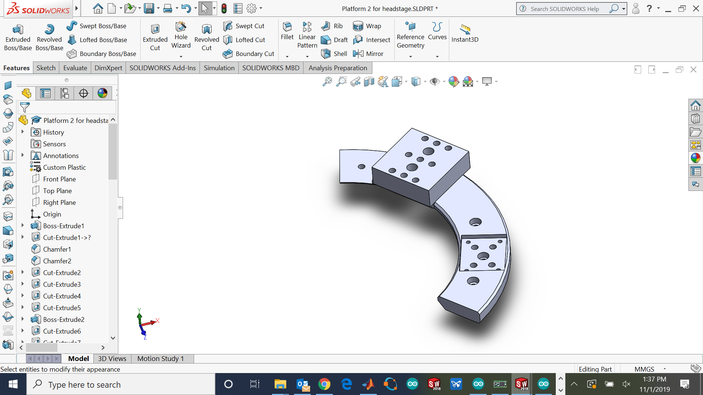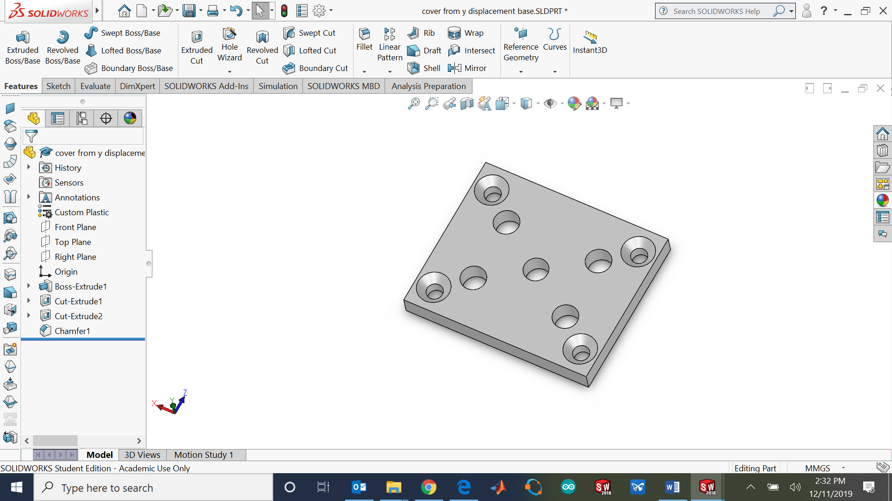
Figure 21: Pupil tracking camera ring (left) and Head fixation and reward delivery system ring (center) and ring cover (right).

Four Thorlabs® bars guide the vertical displacement of the pupil tracking camera and reward delivery systems. The movement of these stages is driven by an M6 screw with the head trapped between the circular ring and the ring cover.
The Thorlabs® bars are composed by three ER3 bars and one ER4E all cut at 58 mm length.
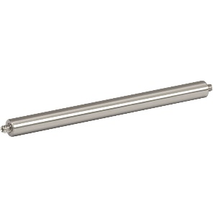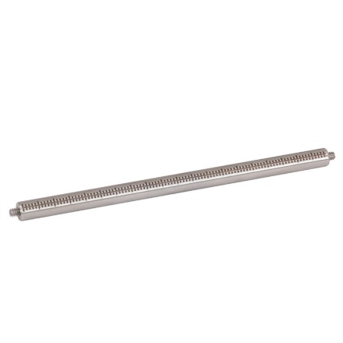
Figure 22: ER3 [9] and ER4E [10] bars.

Bill of materials
Component | Quantity | Supplier | Reference
Ring left | 1 | 3D printed part | Ring left.STL
Ring right | 1 | 3D printed part | Ring right.STL
Spacer | 1 | 3D printed part | Spacer.STL
Ring cover | 2 | 3D printed part | Ring cover.STL
Sphere holder | 1 | 3D printed / CNC machined part | Sphere Holder.STL / Sphere Holder Modified.STL
Cable clamp | 1 | 3D printed part | Cable clamp.STL
Air tube guide | 1 | 3D printed part | Tube guide.STL
Rotary joint spacer | 1 | Metal manufactured part | Rotary joint spacer.STEP / .pdf
Circular platform | 1 | Metal manufactured part | Circular platform.STEP / .pdf
Attachment 2 | 1 | Metal manufactured part | Attachment 2.STEP / .pdf
Square platform | 1 | Thorlabs | MB 3030
Pedestal post (90 mm length) | 4 | Thorlabs | RS3.5P_M
Pedestal clamps | 4 | Thorlabs | CF175-P5
Steinmeyer DT240 rotary stage | 1 | Steinmeyer | DT240-TM
Universal post holders | 2 | Thorlabs | UPH50_M
12.7 mm post | 2 | Thorlabs | TR50_M
Rotary joint (slip ring) | 1 | Senring | SNU11-15S-52301
Pneumatic tube | - | - | -
Tube elbows | - | - | -
Polyestirene sphere | 1 | - | -
Pedestal post (155 mm length) | 6 | Thorlabs | RS6P_M
Cage mounting bar 6 mm | 3 | Thorlabs | ER3
Cage mounting bar 6 mm (Engraved) | 1 | Thorlabs | ER3E
Specially cut M6 screws (DT240) (50 mm) | 4 | - | -
M6 screws (Different sizes) | 40 | - | -
M4 screws | 4 | RS Components | 914-1790
M3 screws | 4 | - | -
UNC 4-40 screws | 8 | RS Components | 717-4505
M4 screws | 8 | RS Components | 908-7510
M4 locking nuts | 8 | RS Components | 524-304

Assembly instructions

- Screw the pedestal posts RS3.5P_M on the square platform MB 3030 using the pedestal clamps CF175.
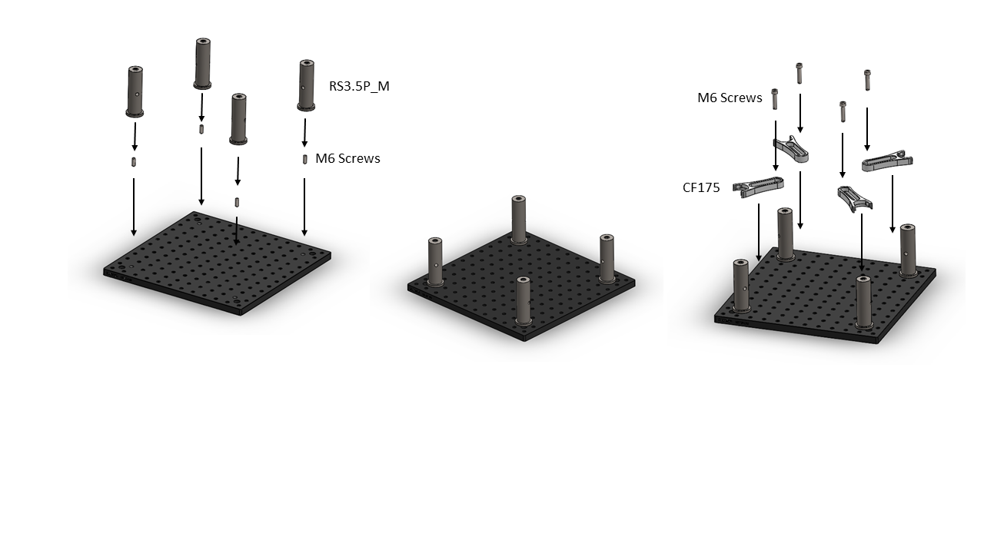
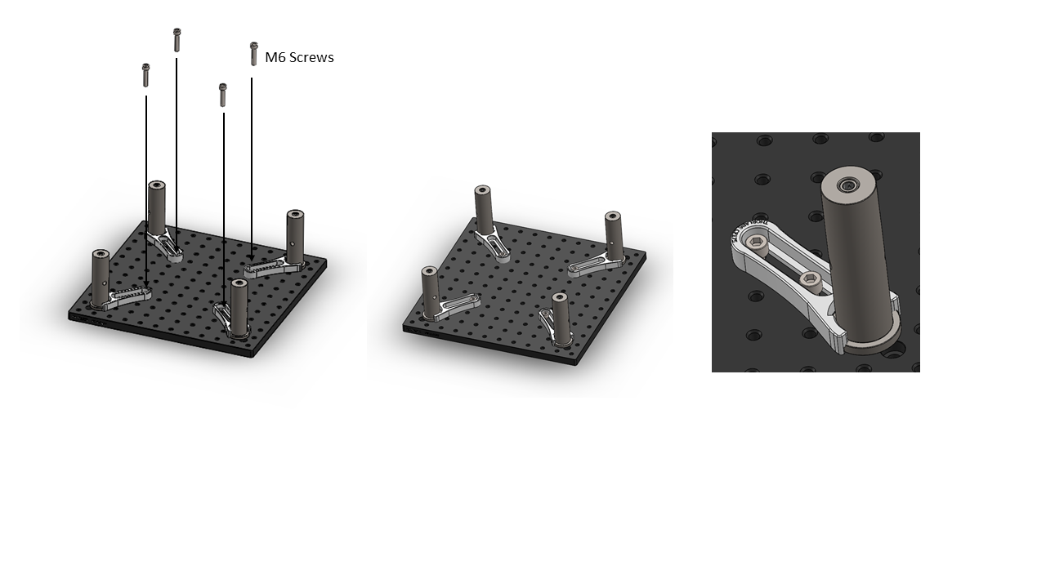
Figure 23: RS3.5P_M and CF175 assembly.

- Place the Senring rotary joint in the center of the platform using the two universal post holders UPH50_M.
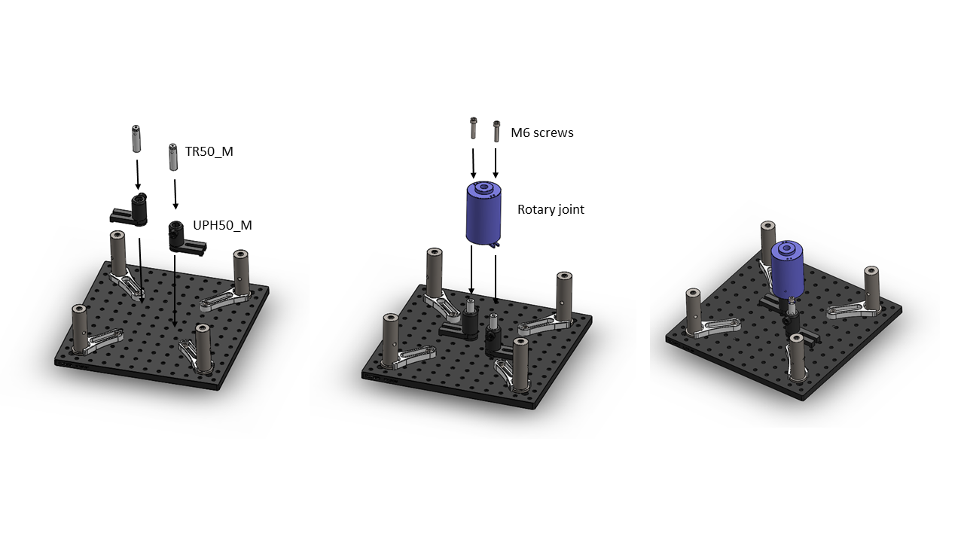
Figure 24: Rotary joint assembly.
- Use the four M3 screws to assemble the rotary joint and the rotary joint spacer.
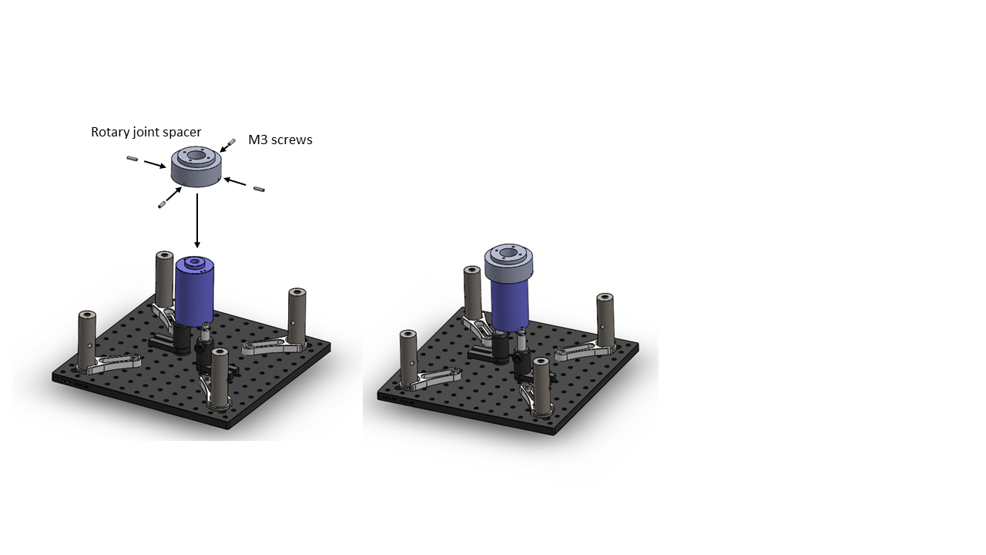
Figure 25: Rotary joint spacer assembly.

- Place the rotary stage DT240-TM coincident with the four modified M6 holes of the pedestal posts.
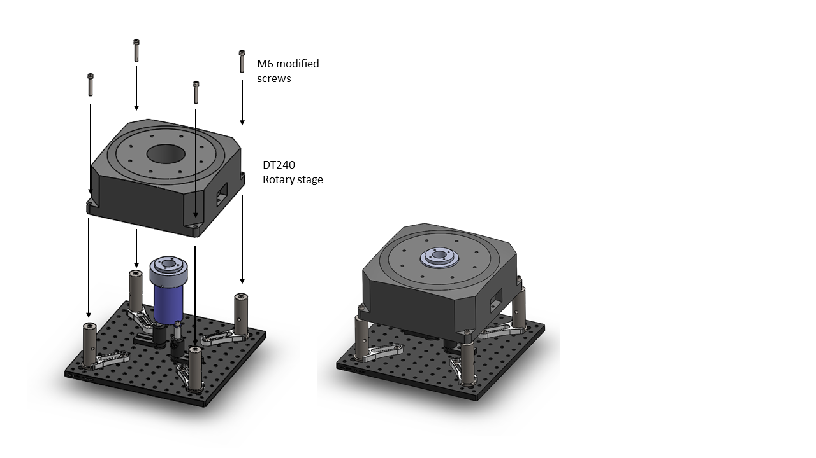
Figure 26: DT240 assembly.
- Place the spacer and the circular platform. Check that the height of the rotary joint spacer surface is coincident with the circular platform top surface. This can be adjusted changing the height of the TR50_M posts.
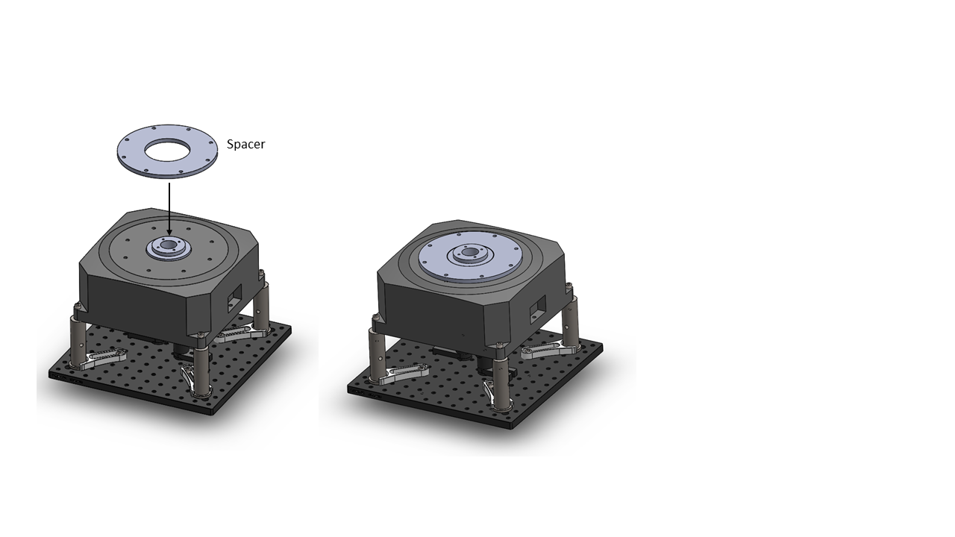
Figure 27: Spacer assembly.

- Insert the tube guide.
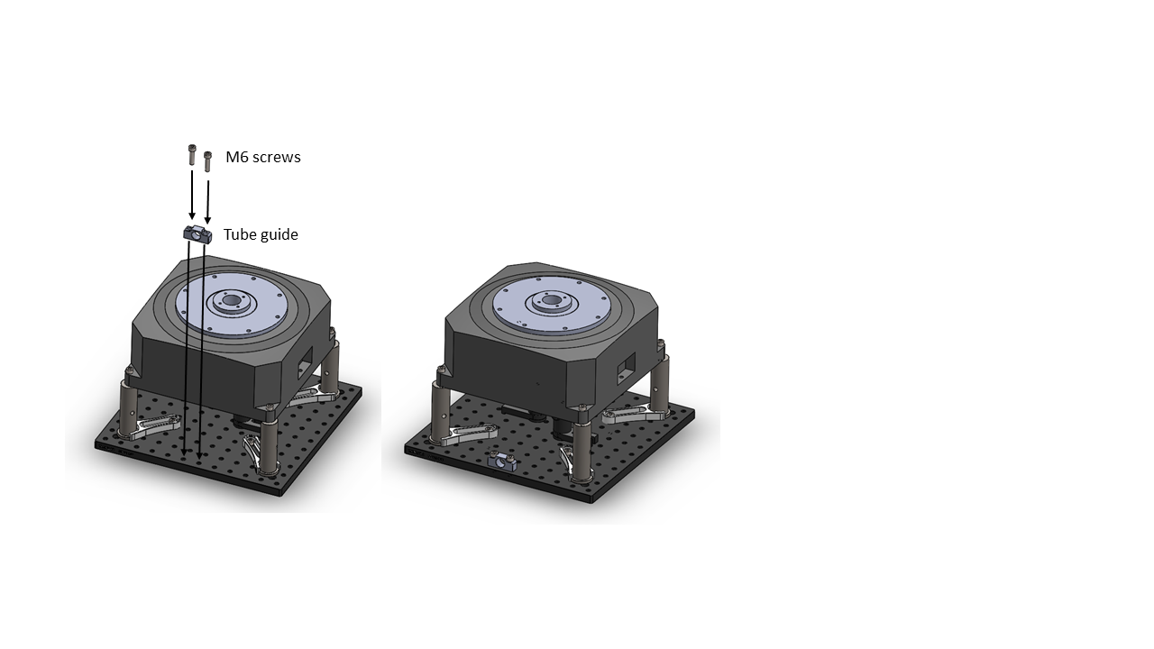
Figure 27: Tube guide assembly.
- Insert the eight M6 screws between the circular platform and the attachment 2.
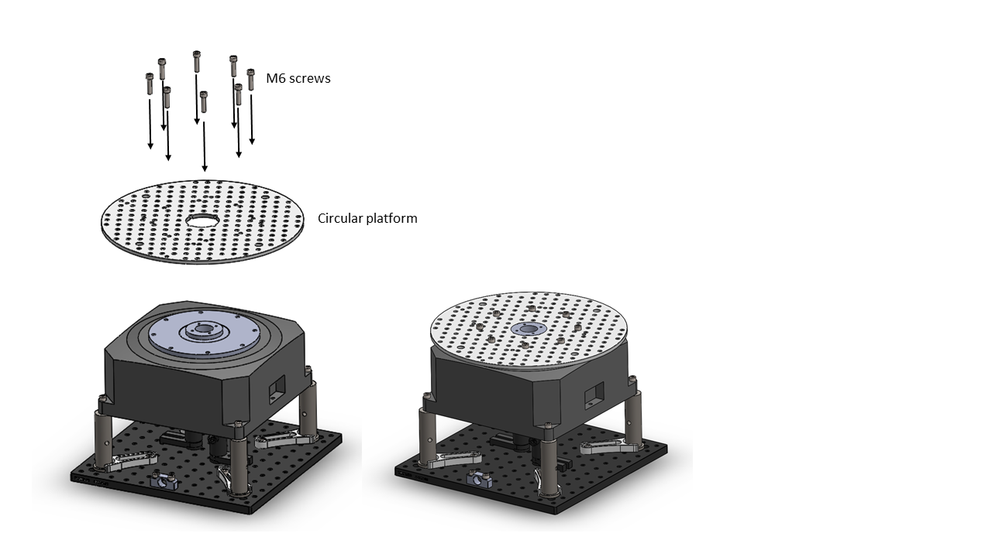
Figure 28: Circular platform assembly.

- Insert the M4 screws and 4 M6 screws between the attachment 2 and the rotary joint.
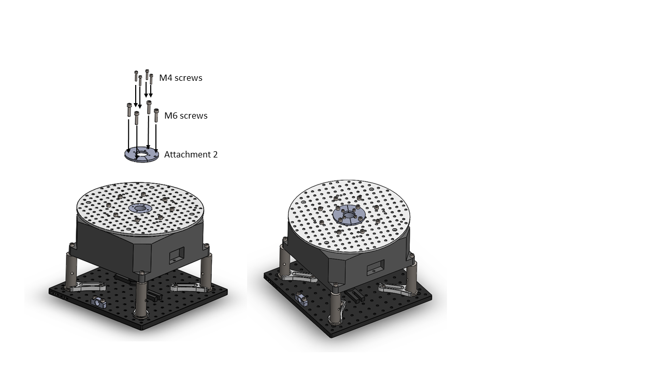
Figure 29: Attachment 2 assembly.
- Place the modified sphere holder on the holder with four M6 screws.
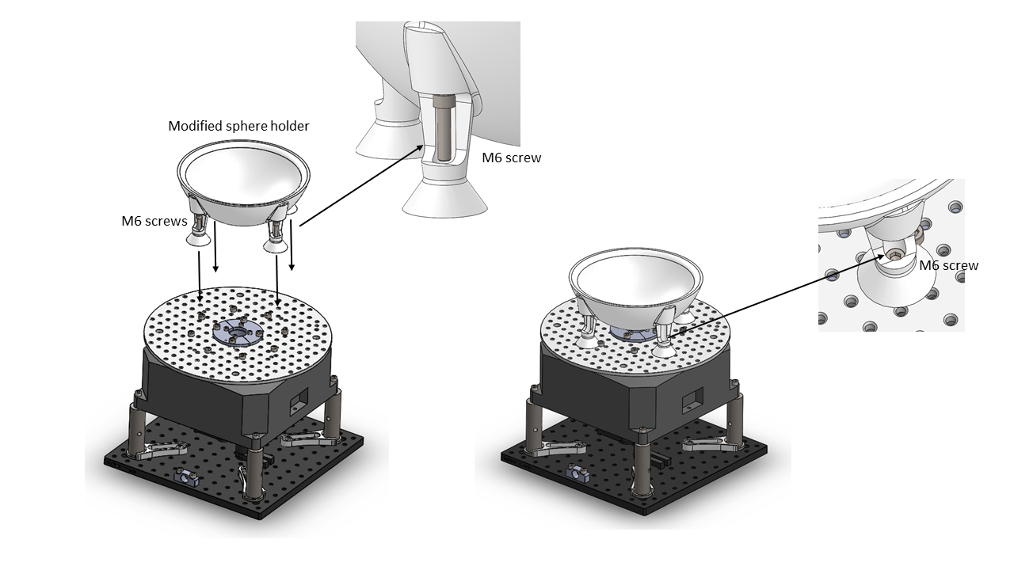
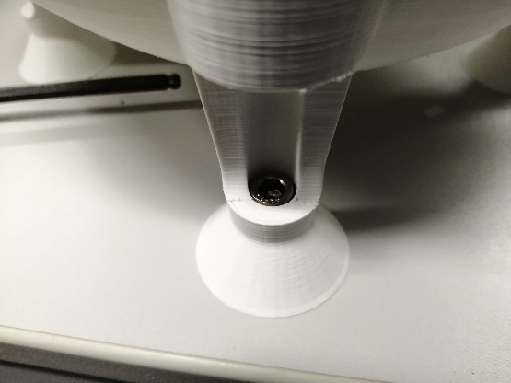
Figure 30: Modified sphere holder assembly.
- Insert the supply tube with the pneumatic elbow and the tube from the top using the sphere holder.
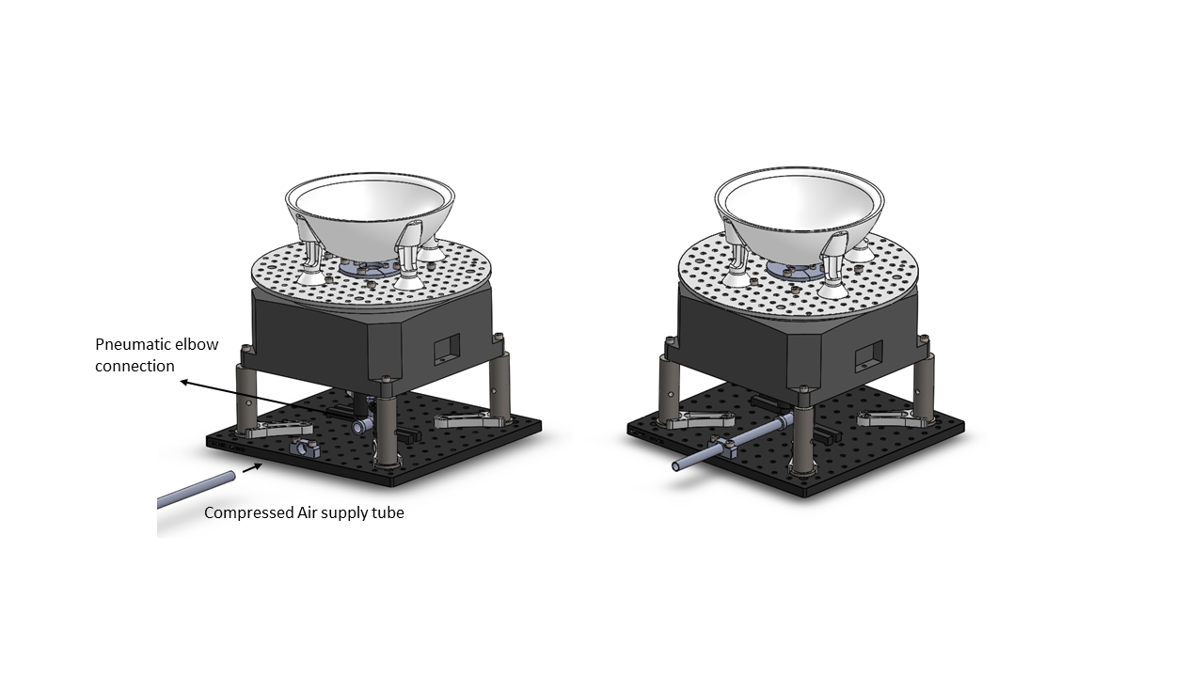
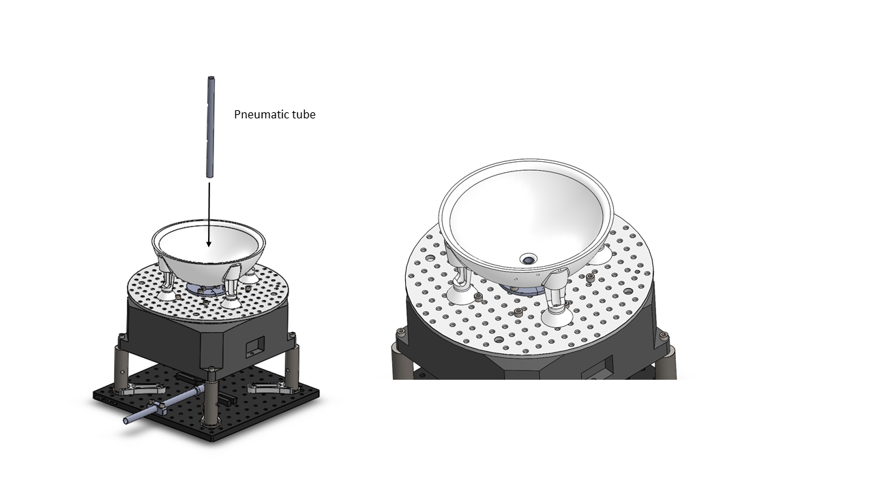
Figure 31: Pneumatic tube assembly.
- Cut the Thorlabs® ER3 ER3E at 58 mm.

- Insert the sphere on the sphere holder.
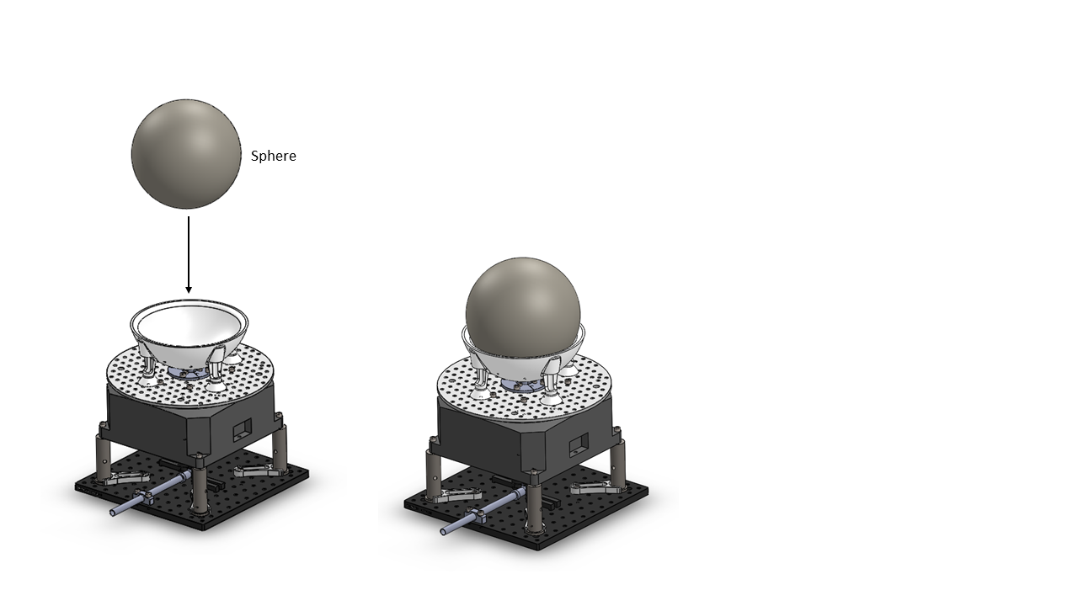
Figure 32: Sphere assembly.
- Insert three ER3 and one ER3E on the left and right rings and screw the UNC 4-40 from the bottom to hold their vertical displacement.
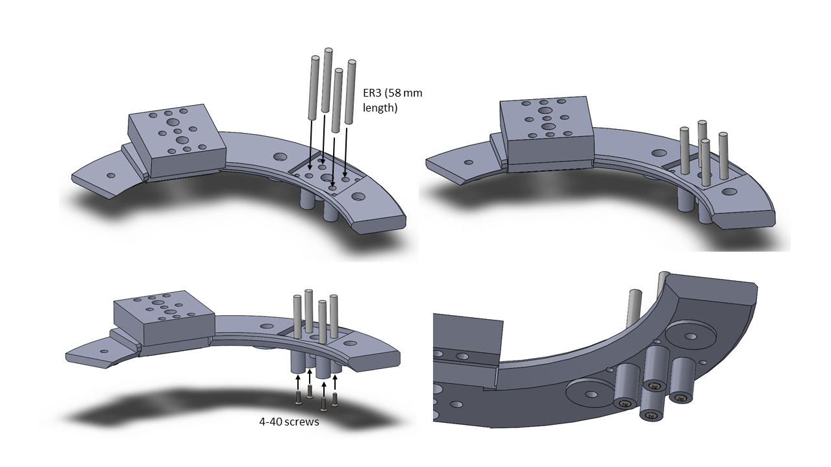
Figure 33: Thorlabs bars placing on the ring assembly.
- Place the head of an M6 hexagonal bolt on the cylindrical space between the four Thorlabs bars and insert the ring cover from the top.
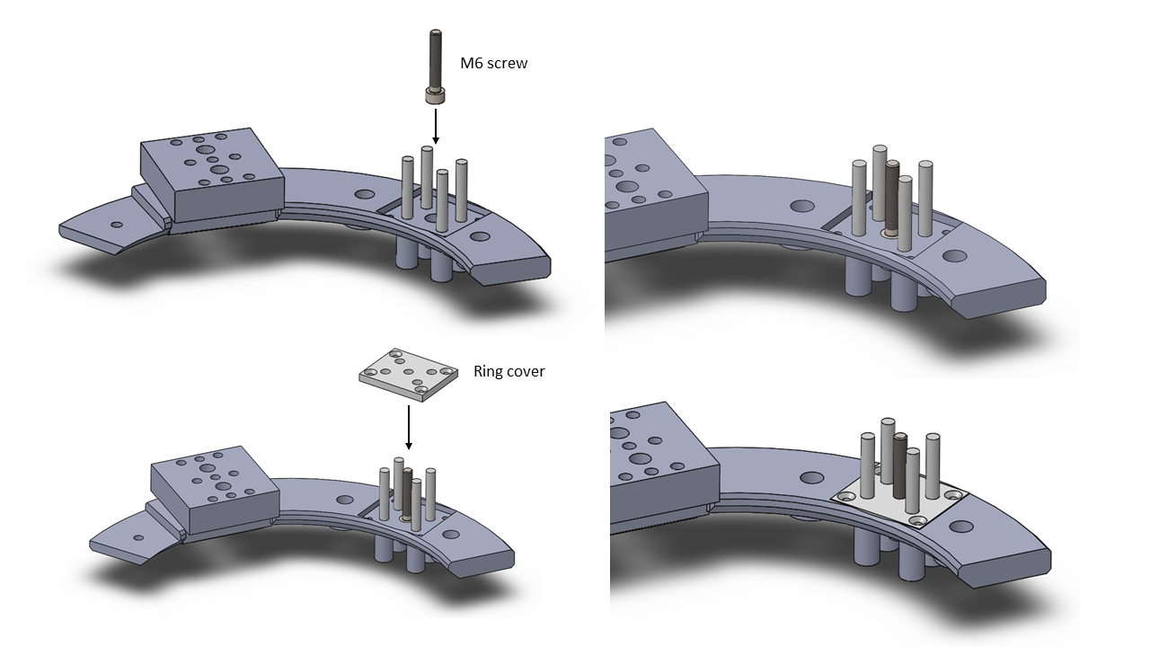
Figure 34: M6 screw and the ring cover placing on the ring assembly.
- Screw the ring cover with four M4 screws with a M4 nut on the other side.
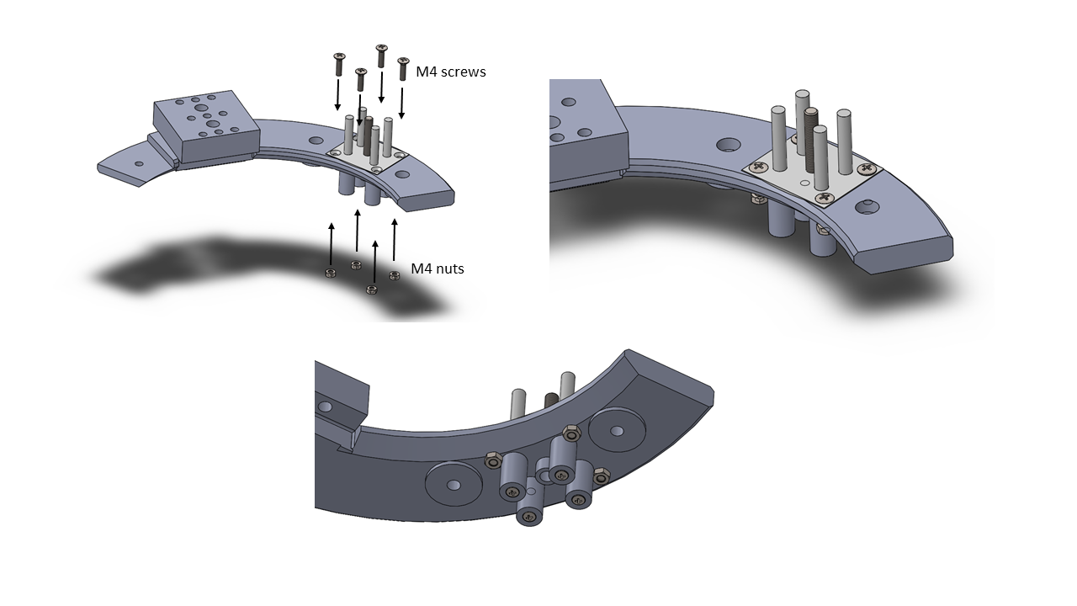
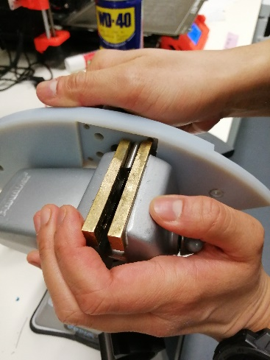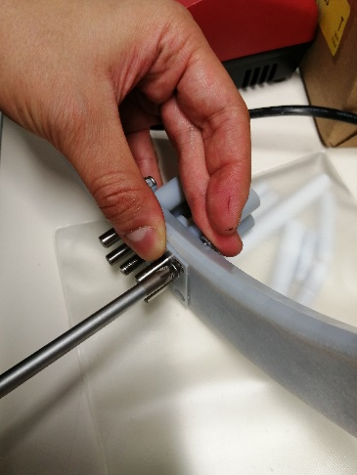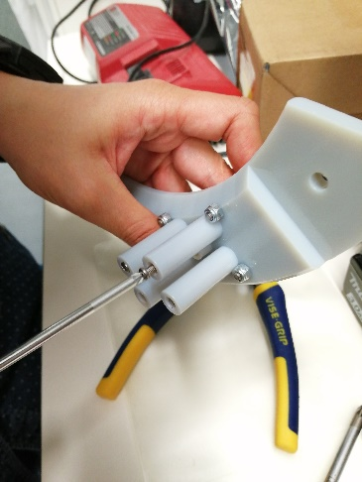
Figure 35: M4 screws and nuts assembly and Thorlabs® bars inserted in the ring 3D printed part tips.
- Place the three 155 mm pedestal posts on the circular platform and the two rings as well all with M6 screws.
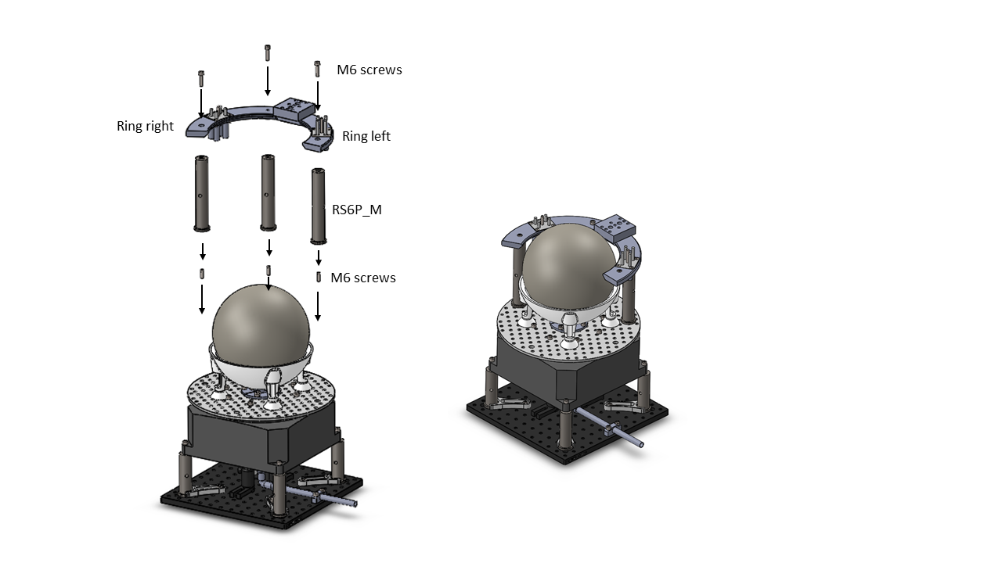
Figure 36: Right and left ring assembly.

- Now, the reward delivery system, the camera orientation system and the head fixation system can be placed on the ring.
- The Optical sensor holders can also be screwed with the circular platform.
- Use a M8 screw to attach the external encoder with the DT240-TM rotary stage.
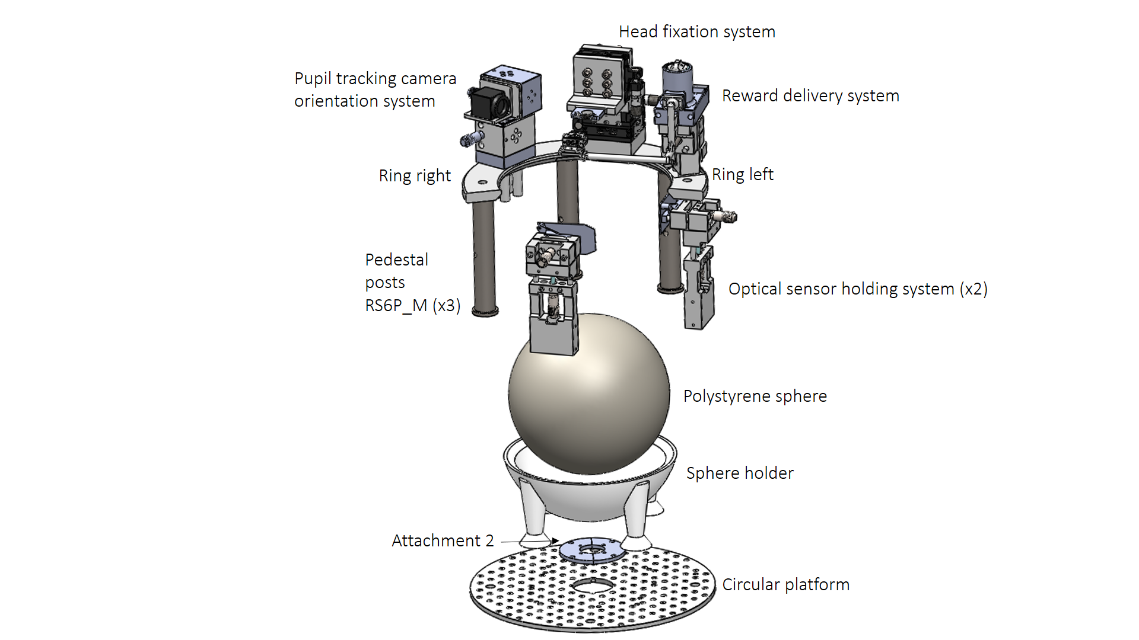
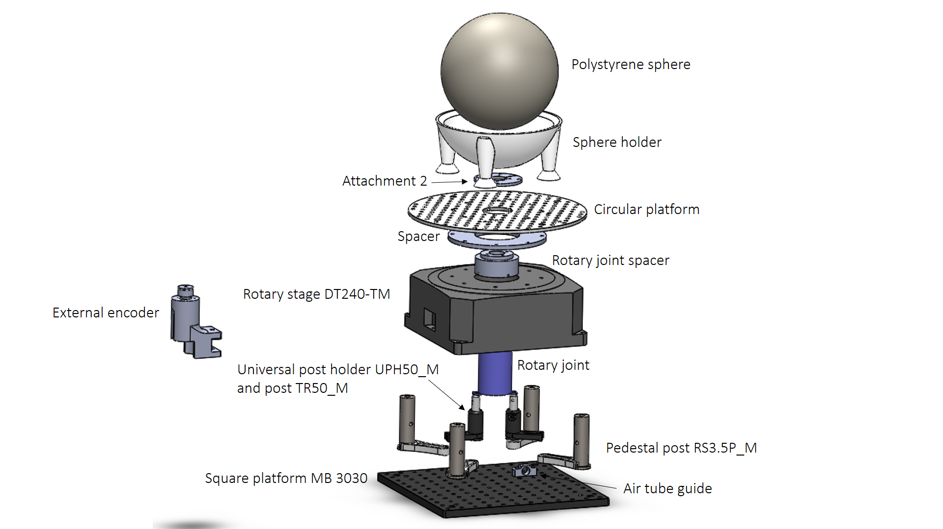
Figure 37: Exploded views of the assembly.
- After the assembly, three posts have to be added to align the center of gravity of the system on the center of rotation. The distribution of the elements on the platform from the top view is shown in Figure 38.
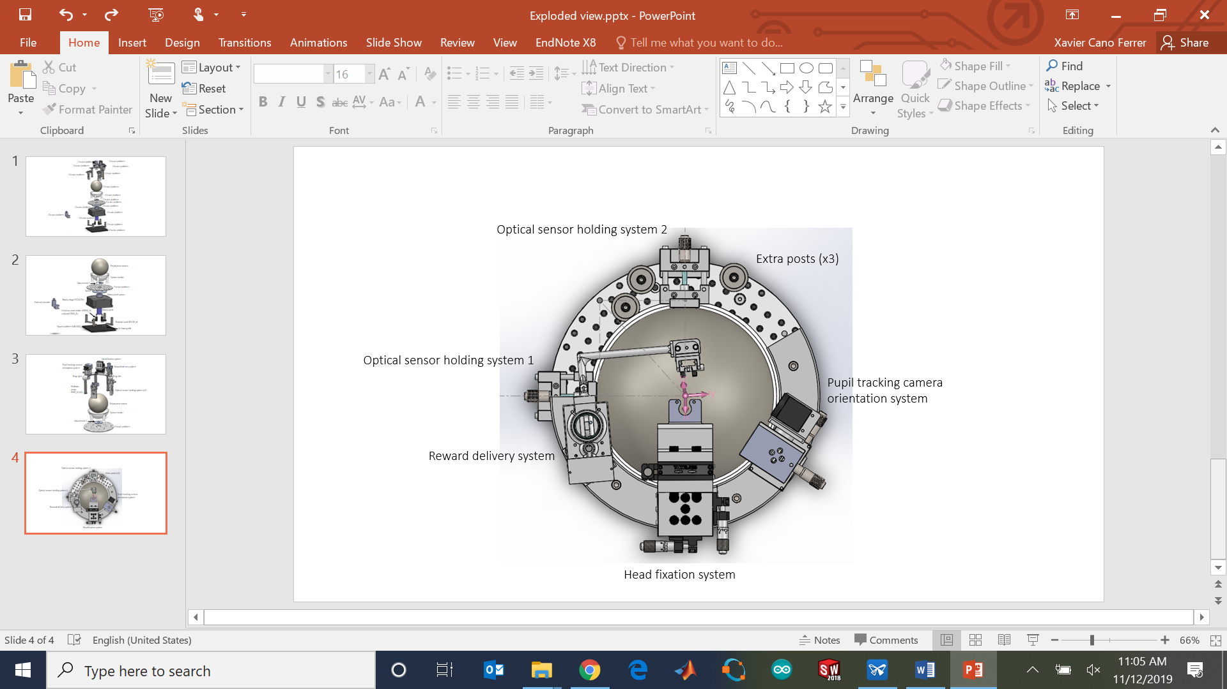
Figure 38: Distribution of the elements on the platform.

References

[1] | "https://www.thorlabs.com/thorproduct.cfm?partnumber=MB3030D/M," [Online].
[2] | "https://www.thorlabs.com/thorproduct.cfm?partnumber=RS3.5P/M," [Online].
[3] | "https://www.thorlabs.de/thorproduct.cfm?partnumber=CF175-P5," [Online].
[4] | "https://www.steinmeyer-mechatronik.de/en/products/standardaxes/rotary-stages/dt240-tm/," [Online].
[5] | "https://www.thorlabs.com/thorproduct.cfm?partnumber=UPH50/M," [Online].
[6] | "https://www.thorlabs.com/thorproduct.cfm?partnumber=TR50/M," [Online].
[7] | "https://www.senring.com/pdf/u/Senring-UH1256-01-Series-SlipRing-Catalog.pdf," [Online].
[8] | "https://www.thorlabs.com/thorproduct.cfm?partnumber=RS6P/M," [Online].
[9] | "https://www.thorlabs.com/thorproduct.cfm?partnumber=ER3," [Online].
[10] | "https://www.thorlabs.com/thorproduct.cfm?partnumber=ER4E," [Online].
[11] | "https://www.thorlabs.com/newgrouppage9.cfm?objectgroup_ID=159," [Online].
[12] | "https://www.thorlabs.com/newgrouppage9.cfm?objectgroup_id=7962," [Online].

